**SQL screenshot of executed queries**

Lesson 1: SELECT queries 101

1.Find the **title** of each film

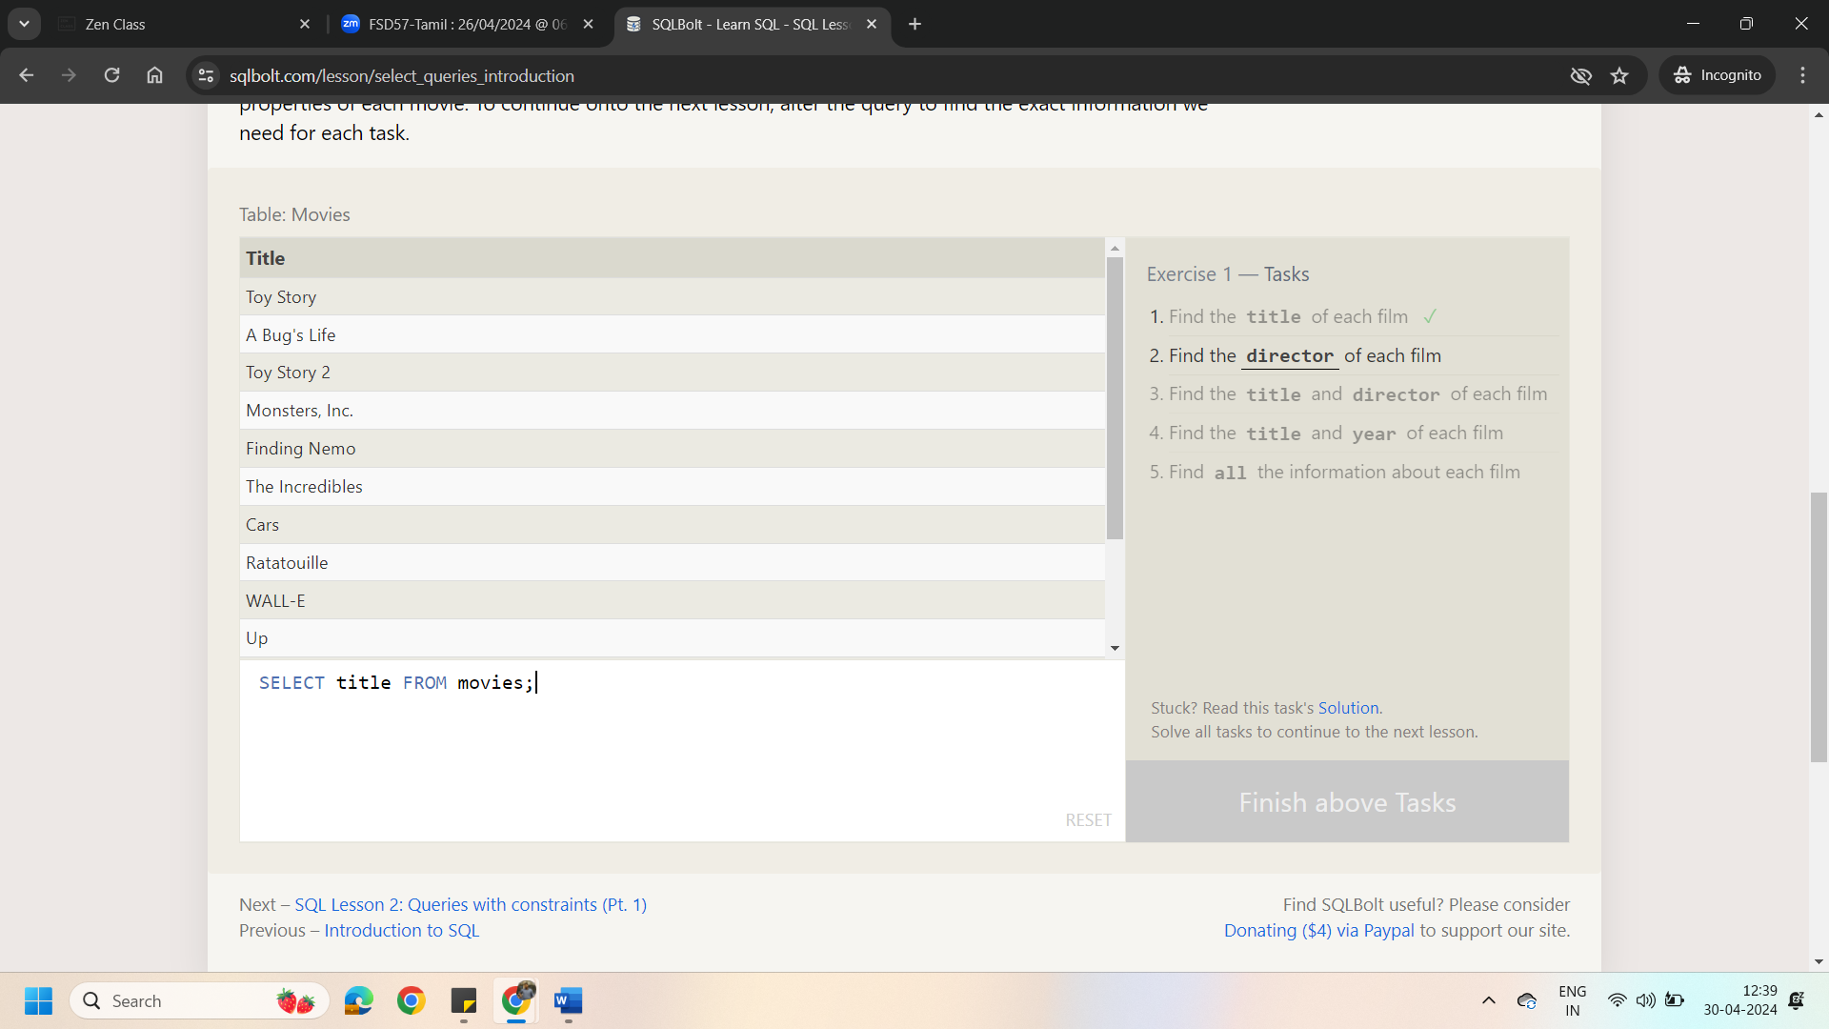

2.Find the **director** of each film

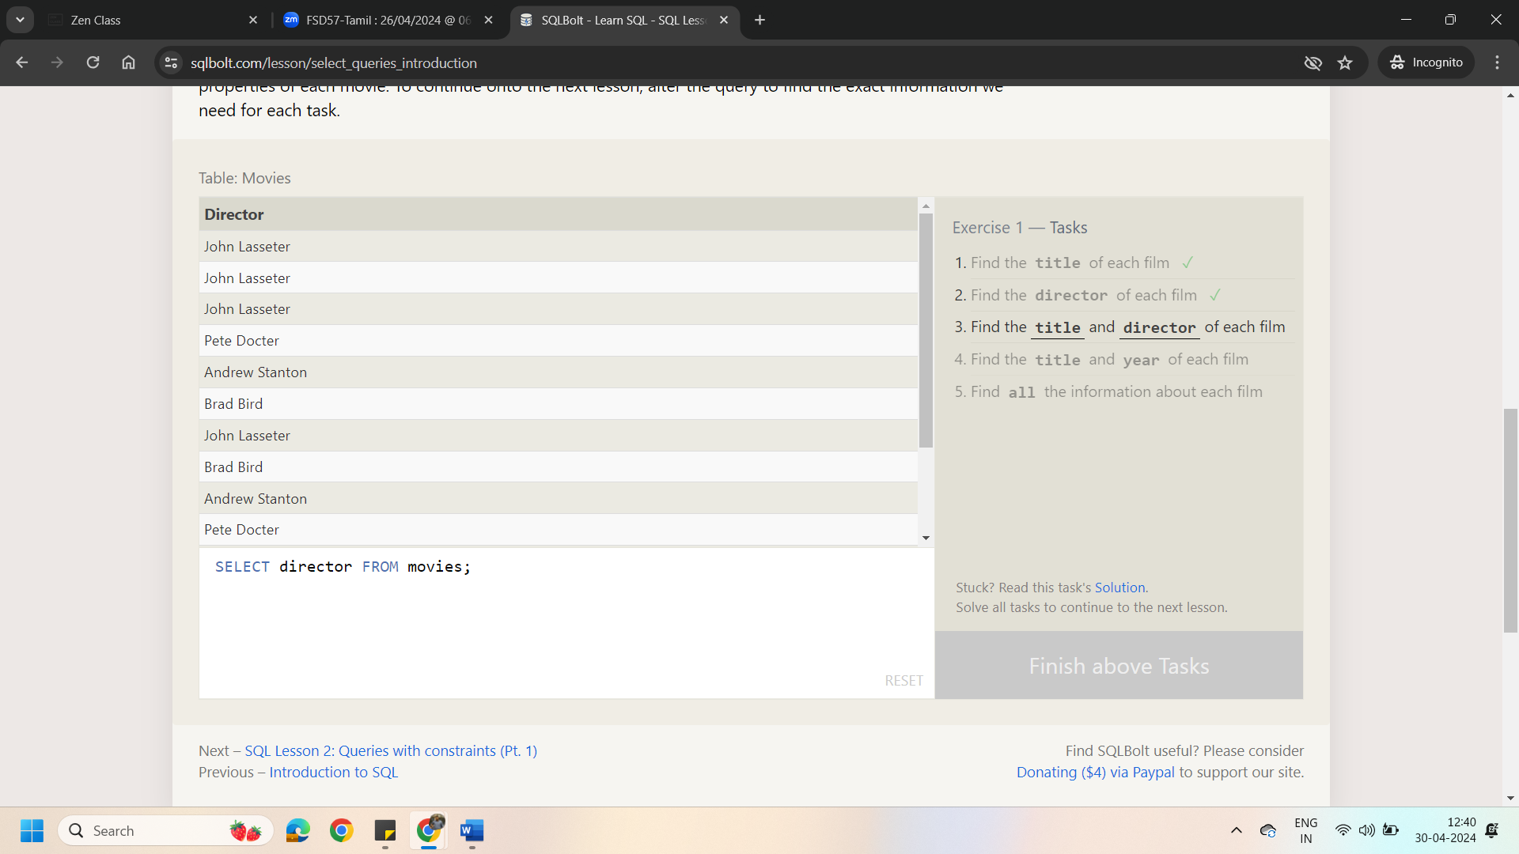

3.Find the **title** and **director** of each film

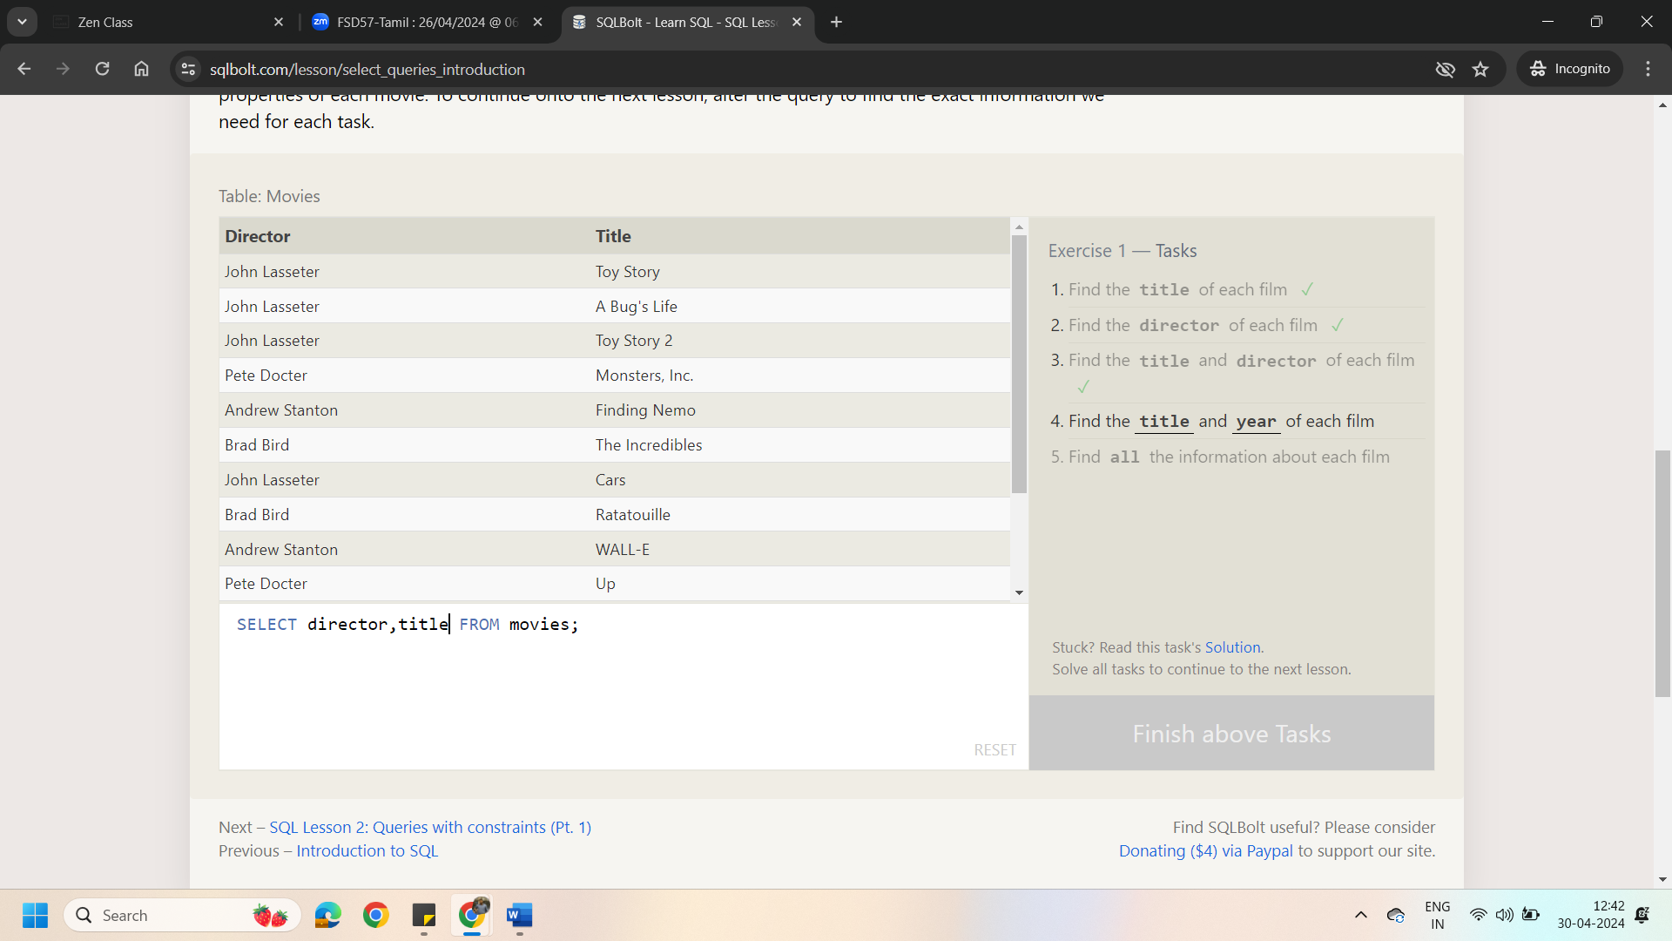

1.Find the **title** and **year** of each film

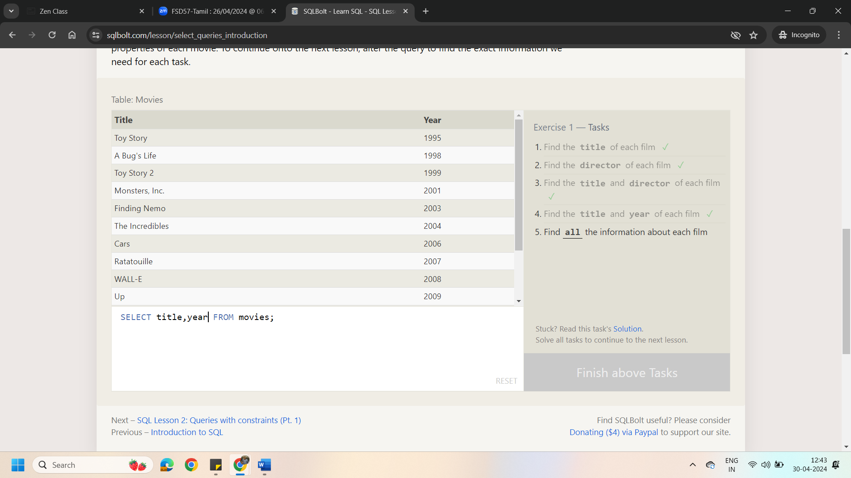

5.Find **all** the information about each film

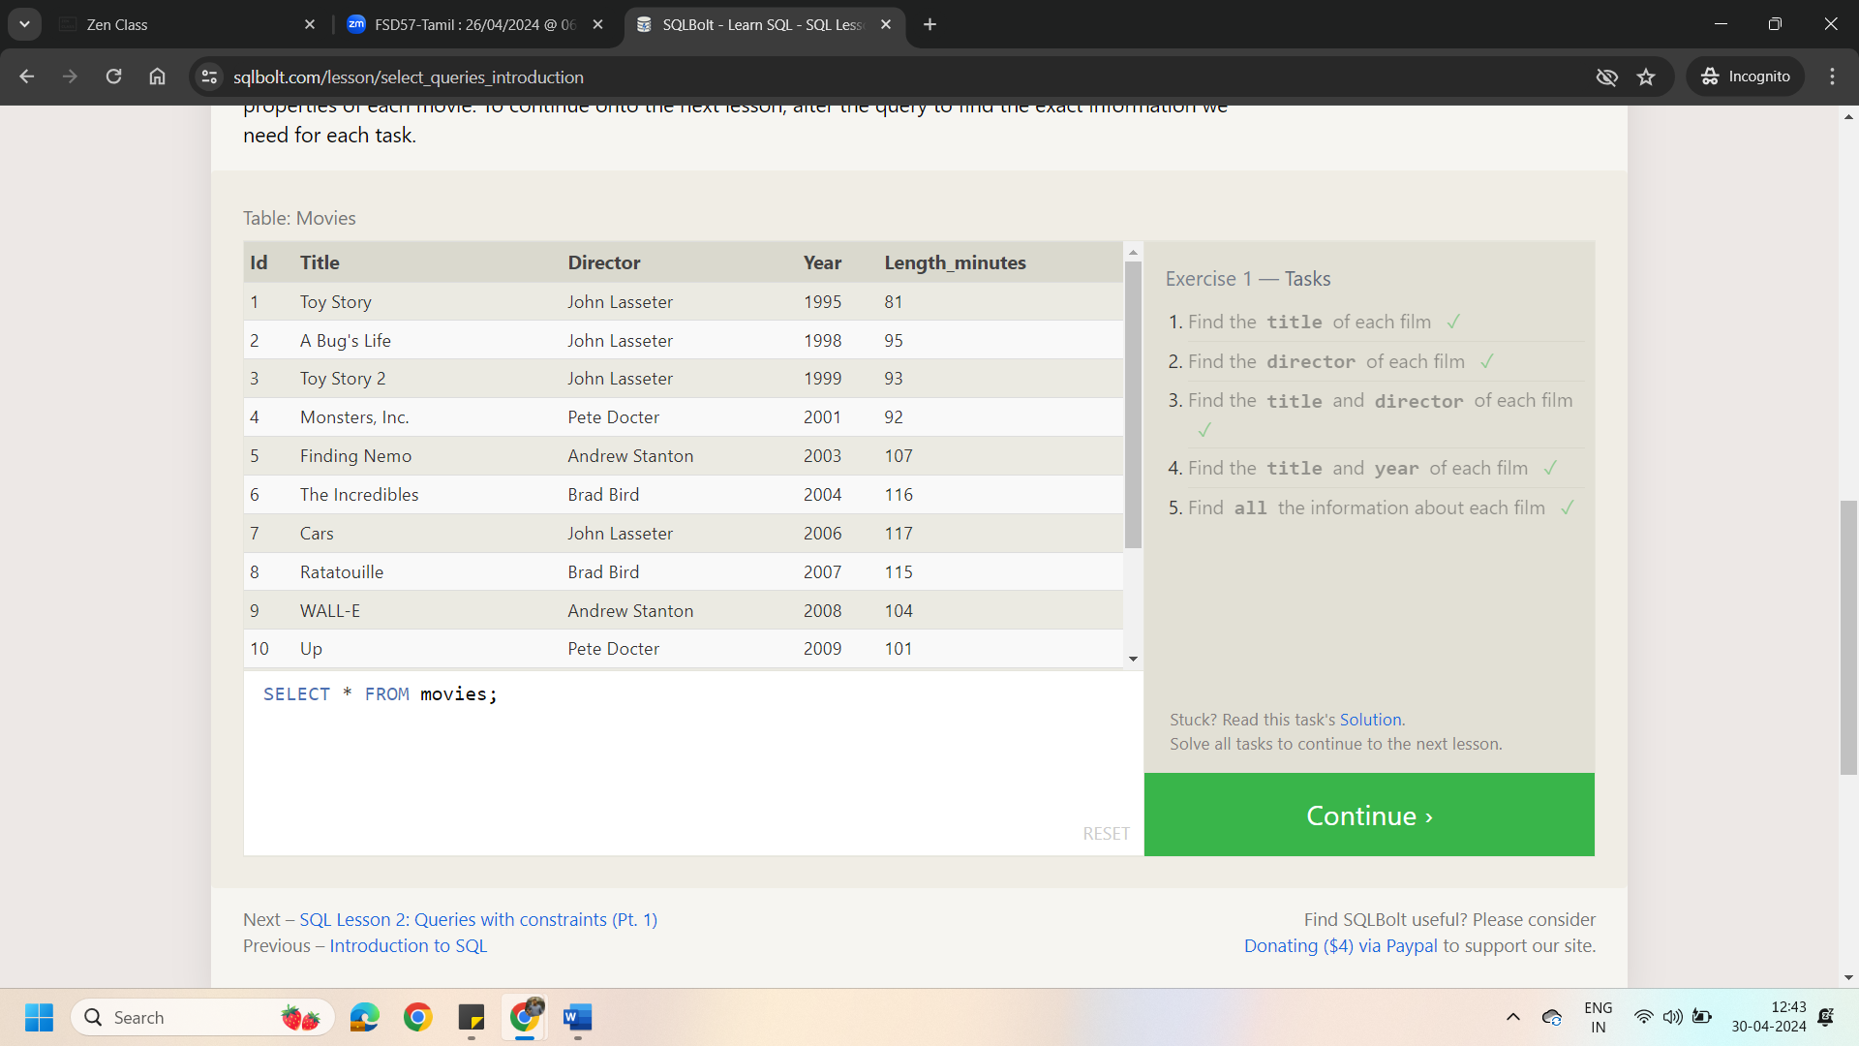

Lesson 2: Queries with Constraints (Pt.1)

1.Find the movie with a row **id** of 6

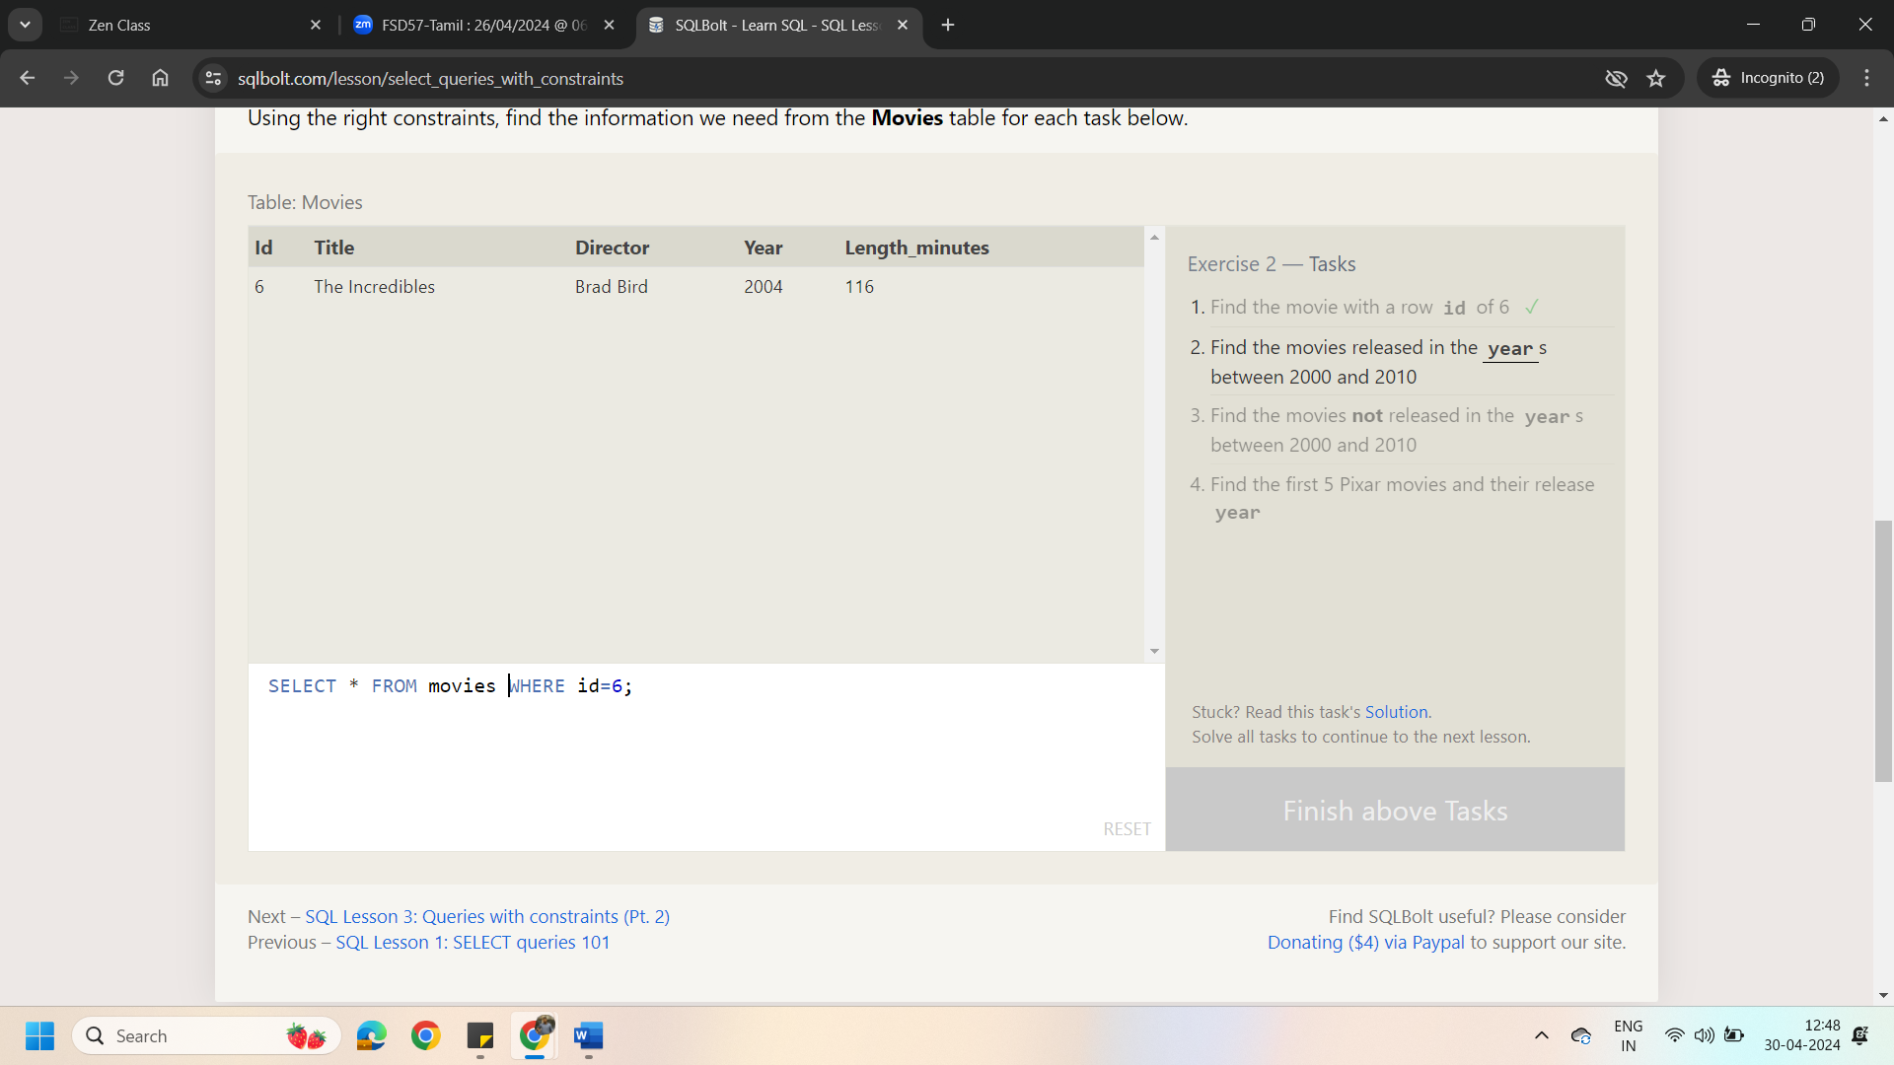

2.Find the movies released in the **year**s between 2000 and 2010

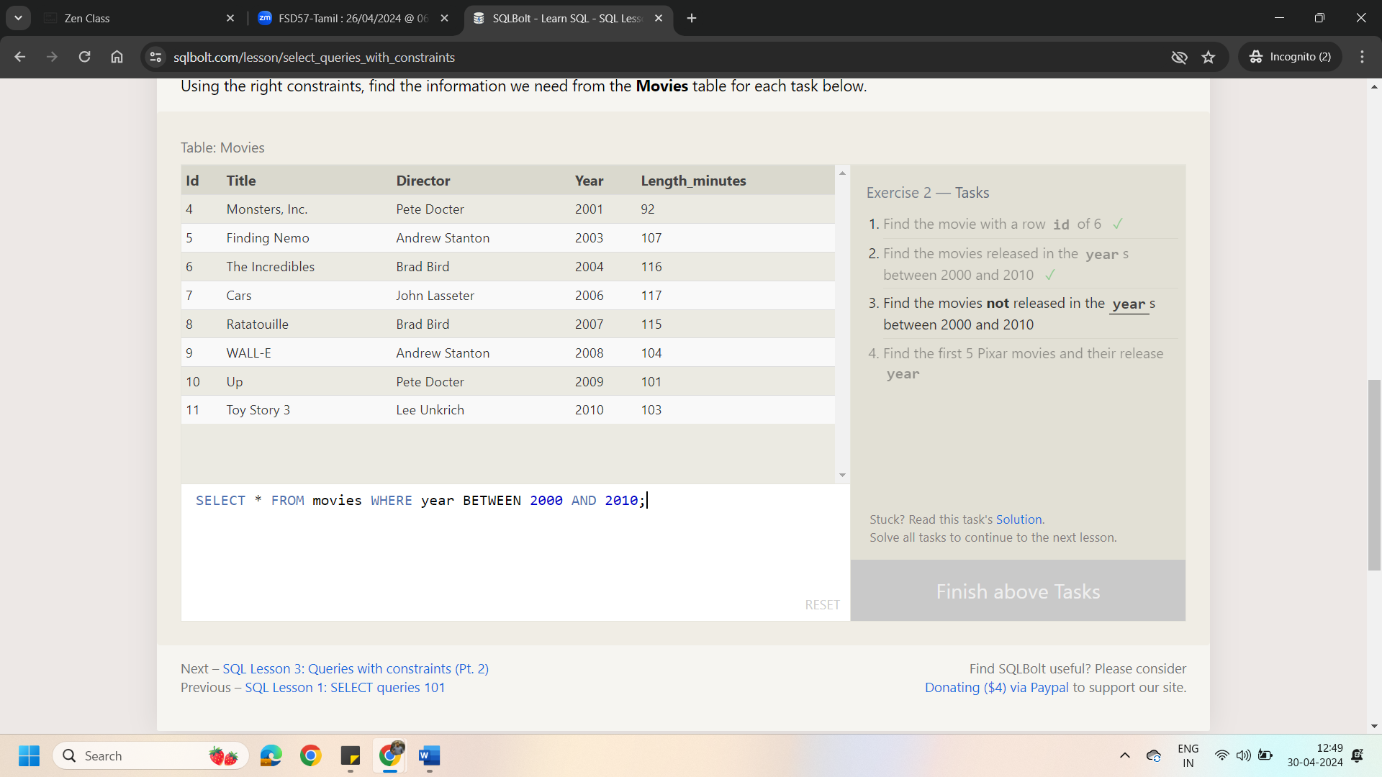

3.Find the movies **not** released in the **year**s between 2000 and 2010

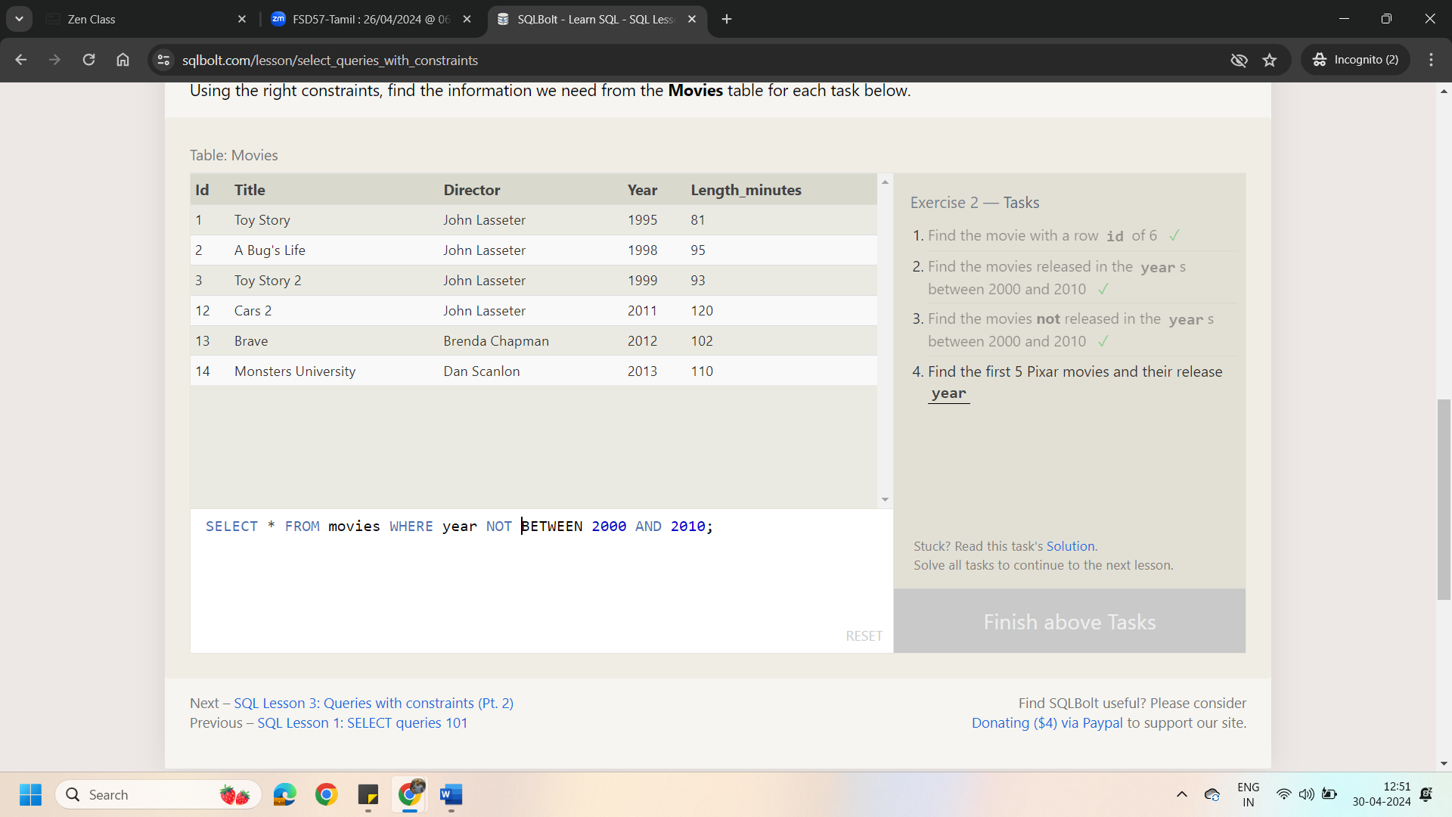

4.Find the first 5 Pixar movies and their release **year**

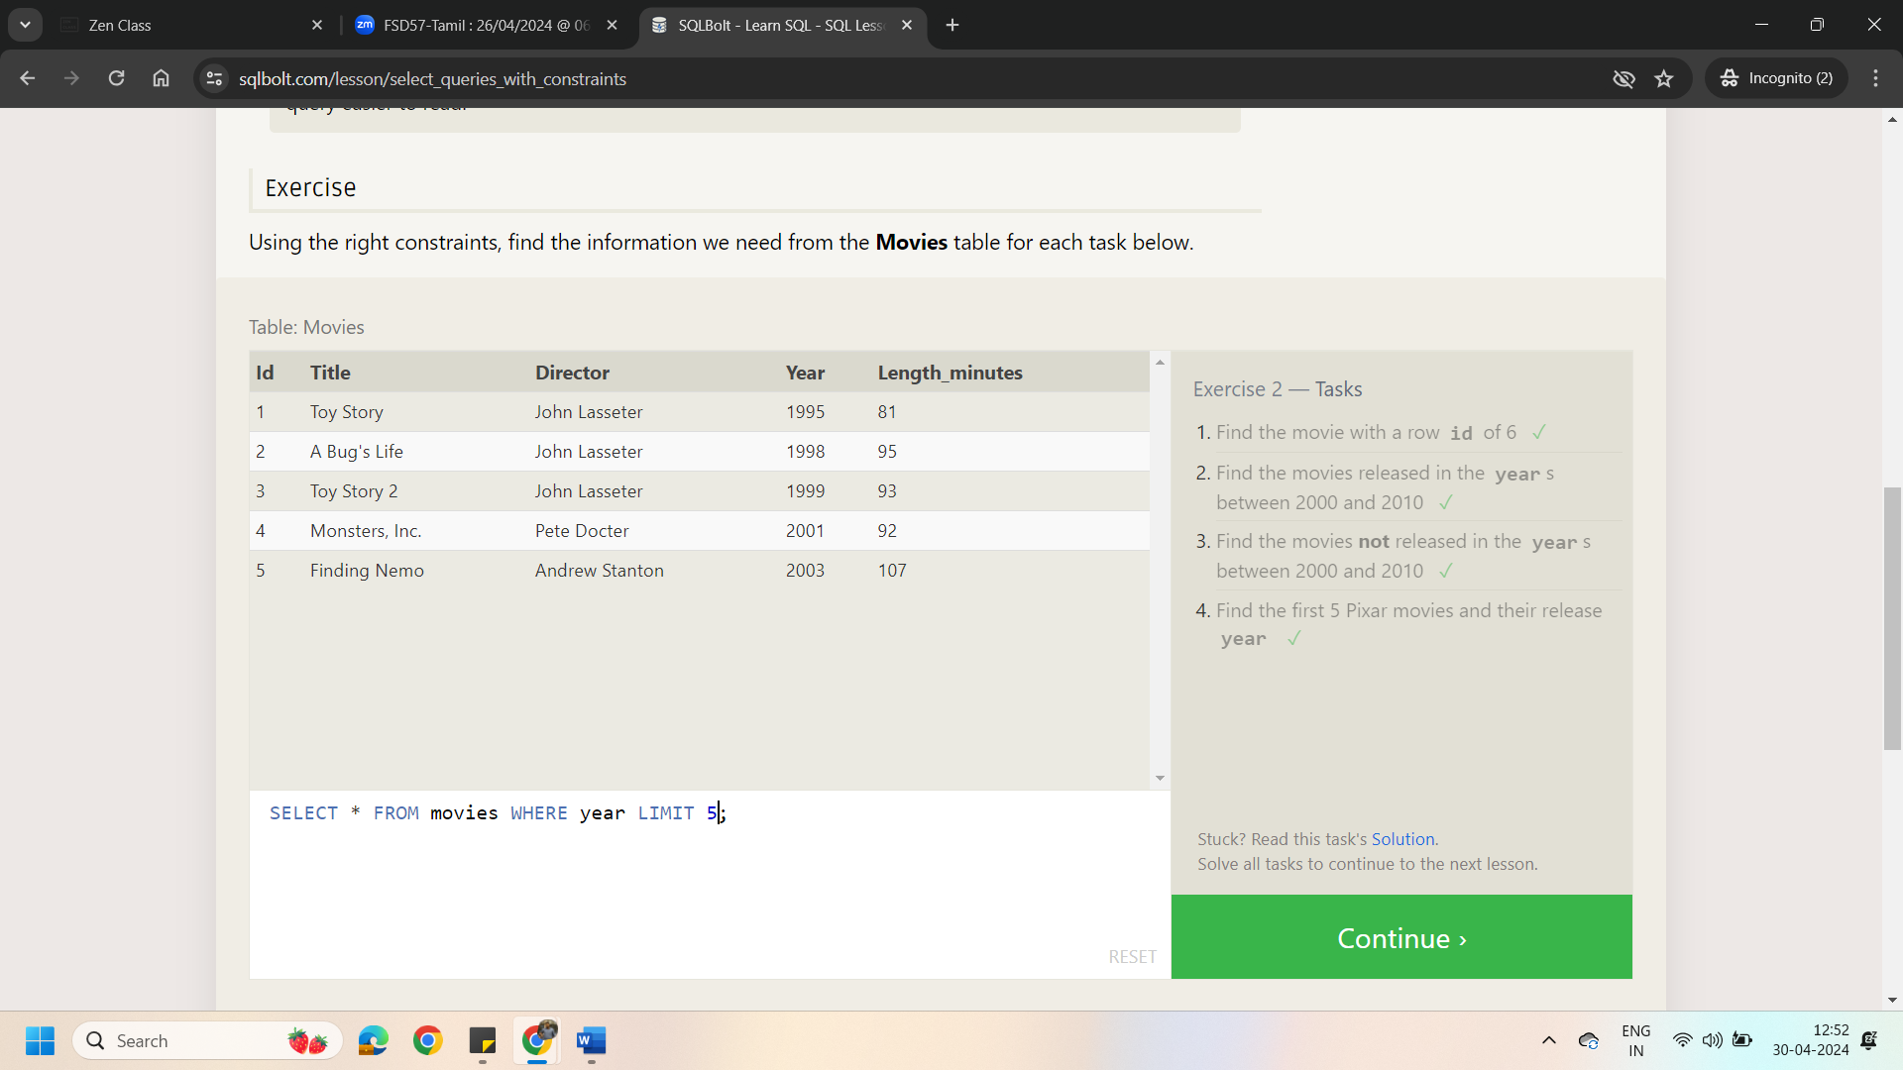

Lesson 3: Queries with Constraints (Pt.2)

1.Find all the Toy Story movies

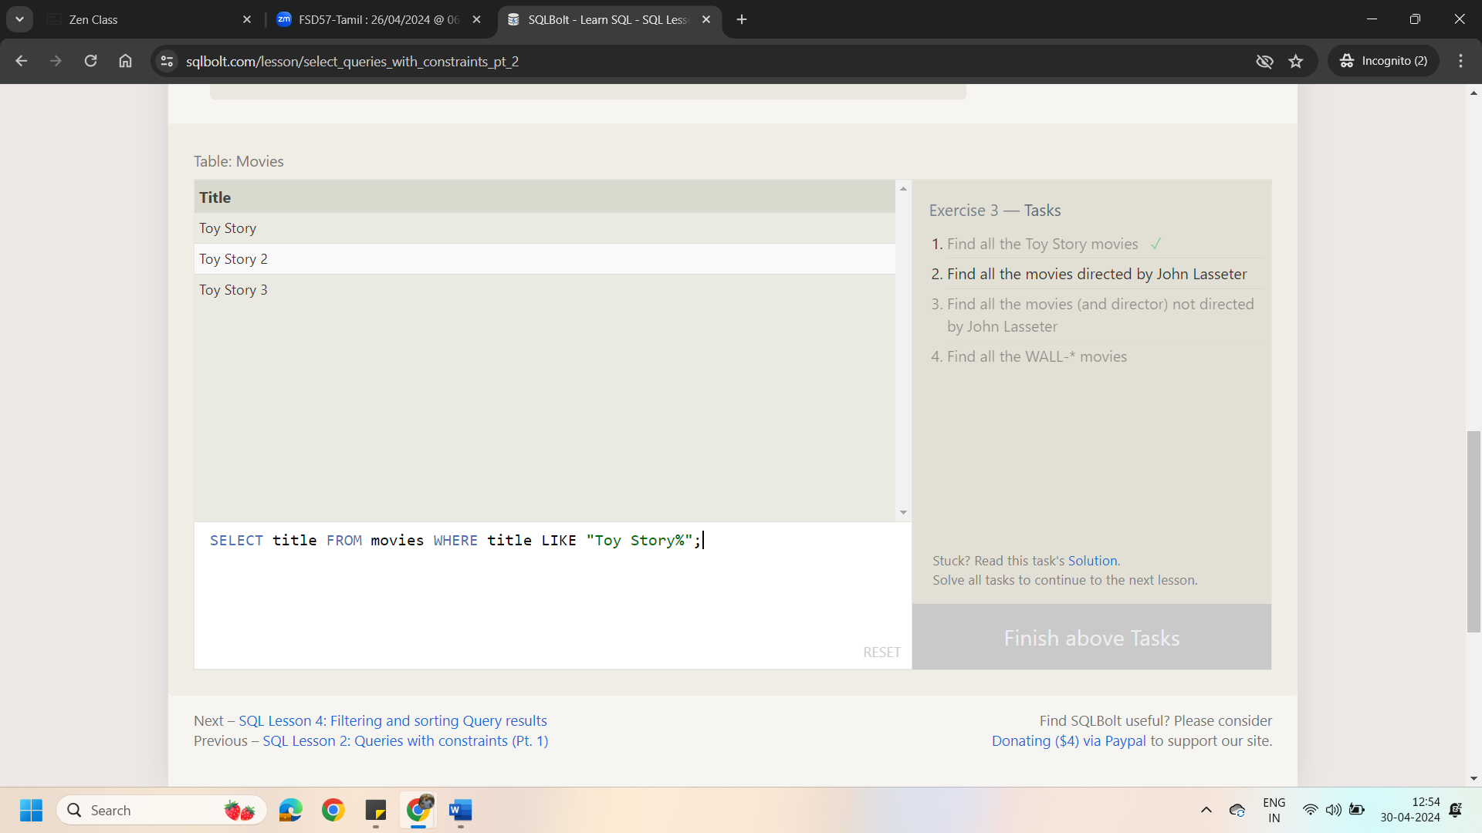

2.Find all the movies directed by John Lasseter

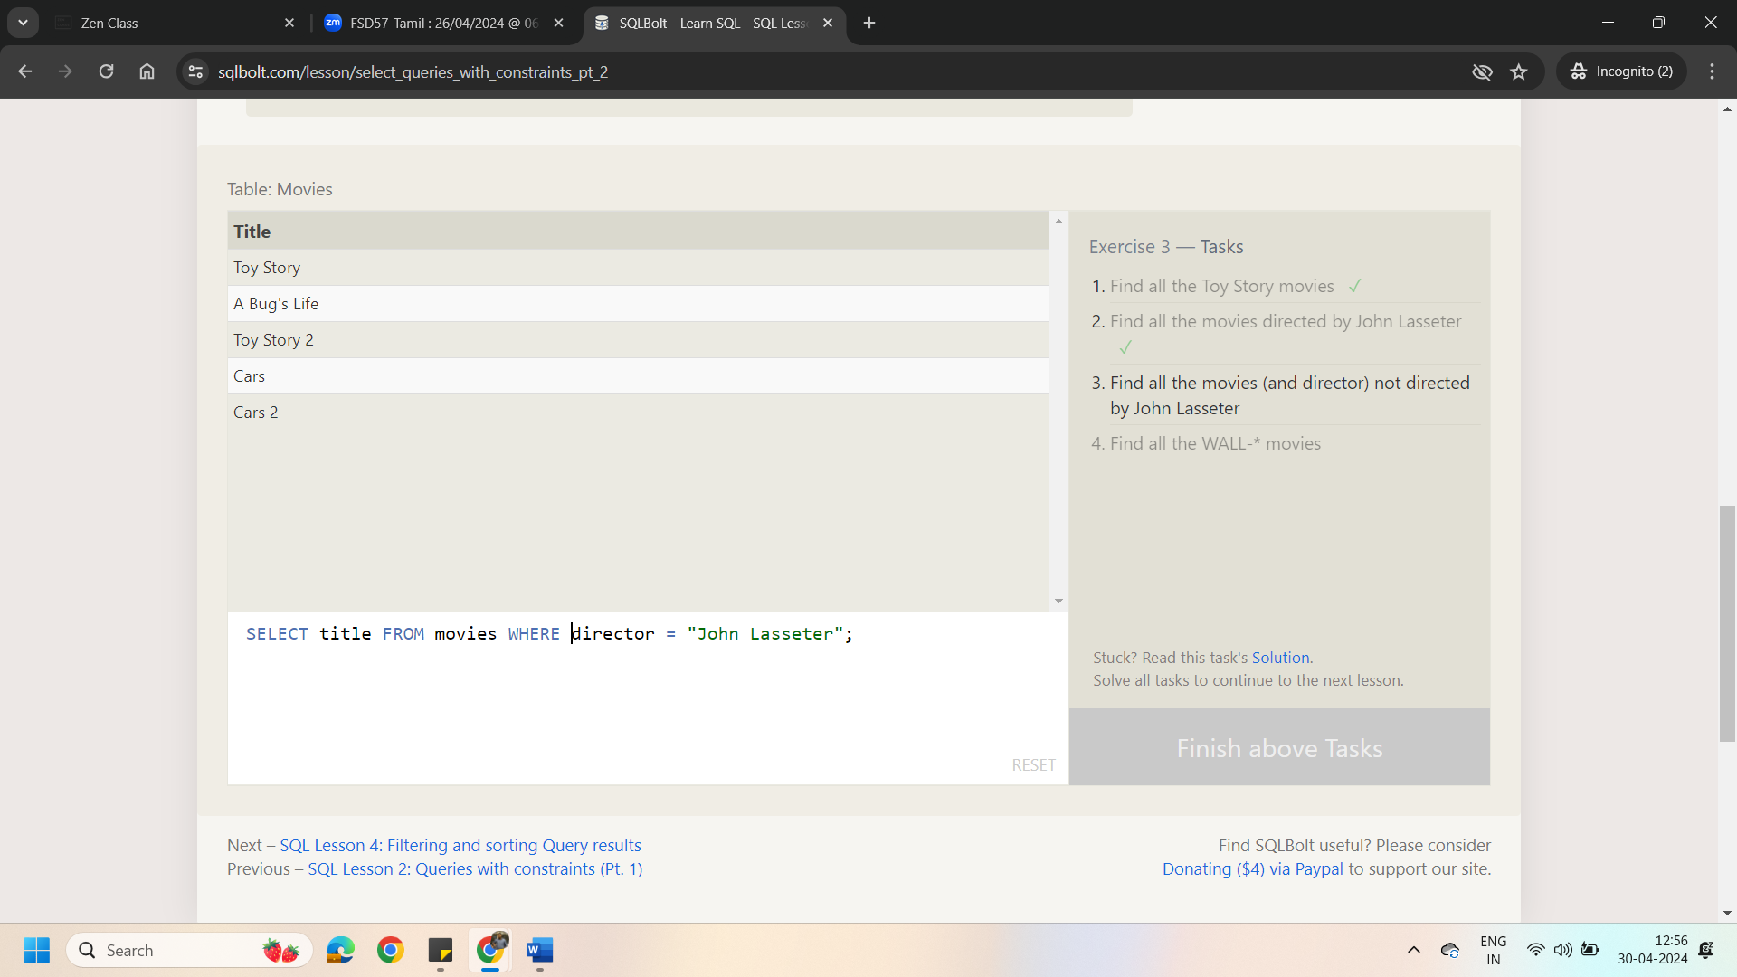

3.Find all the movies (and director) not directed by John Lasseter

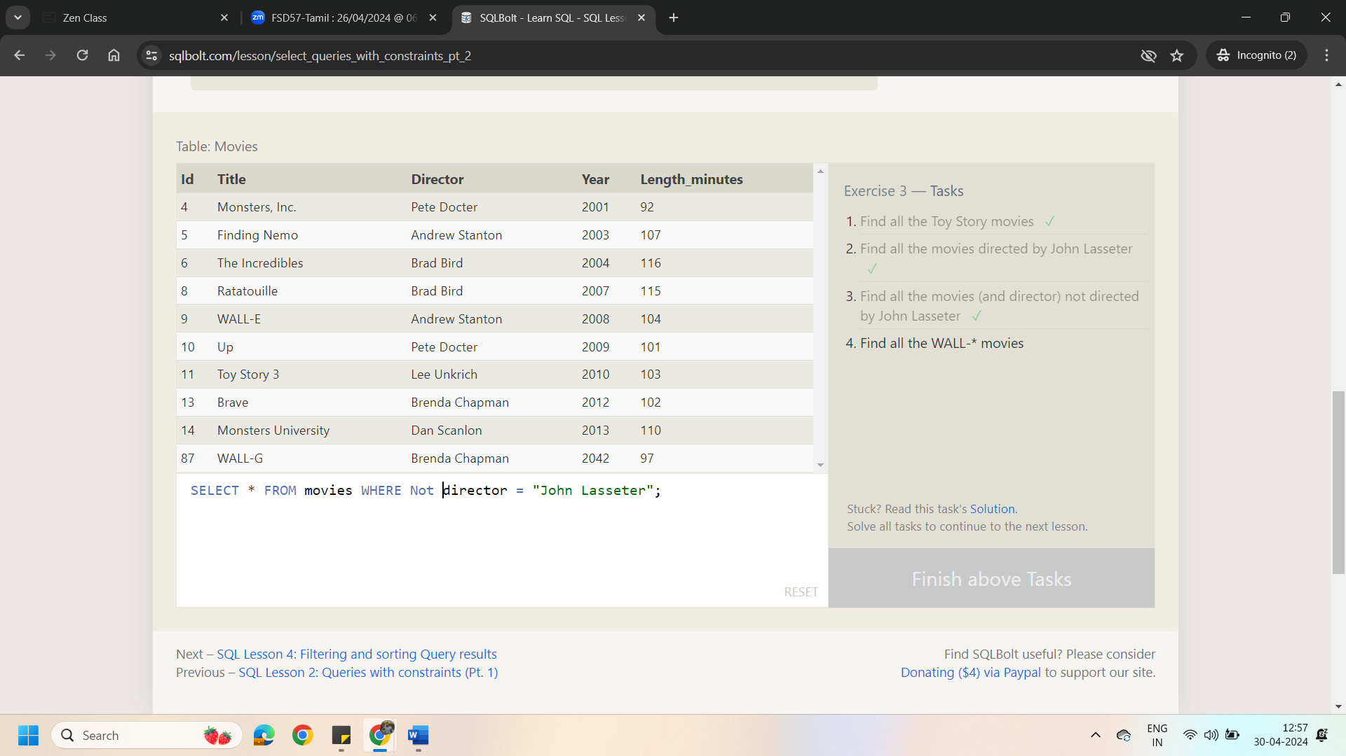

4.Find all the WALL-* movies

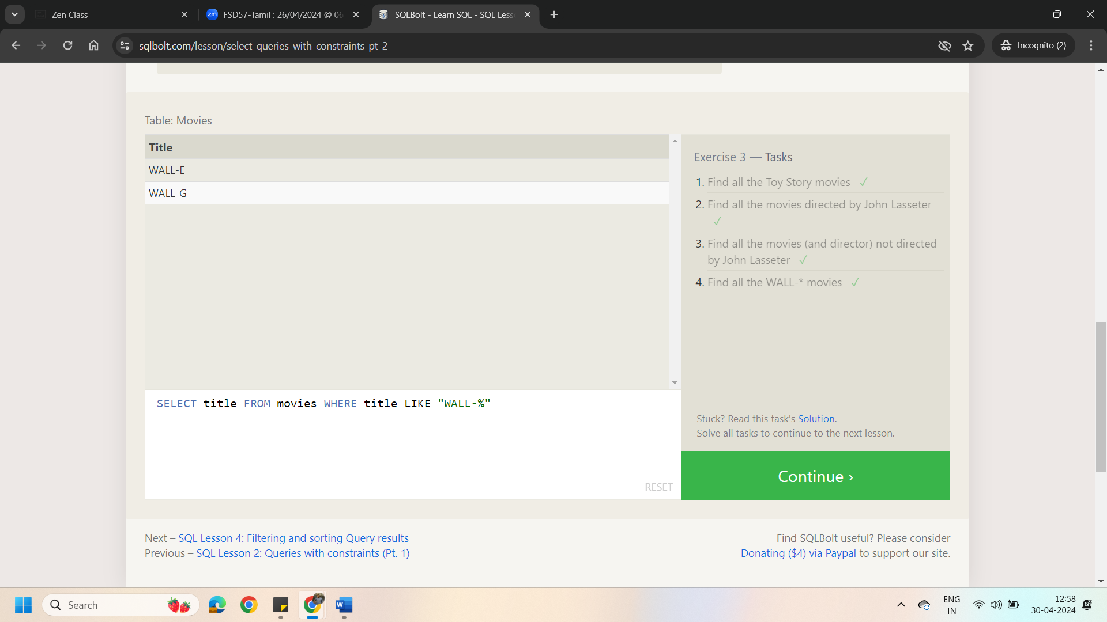

Lesson 4: Filtering and Sorting Query Results

1.List all directors of Pixar movies (alphabetically), without duplicates

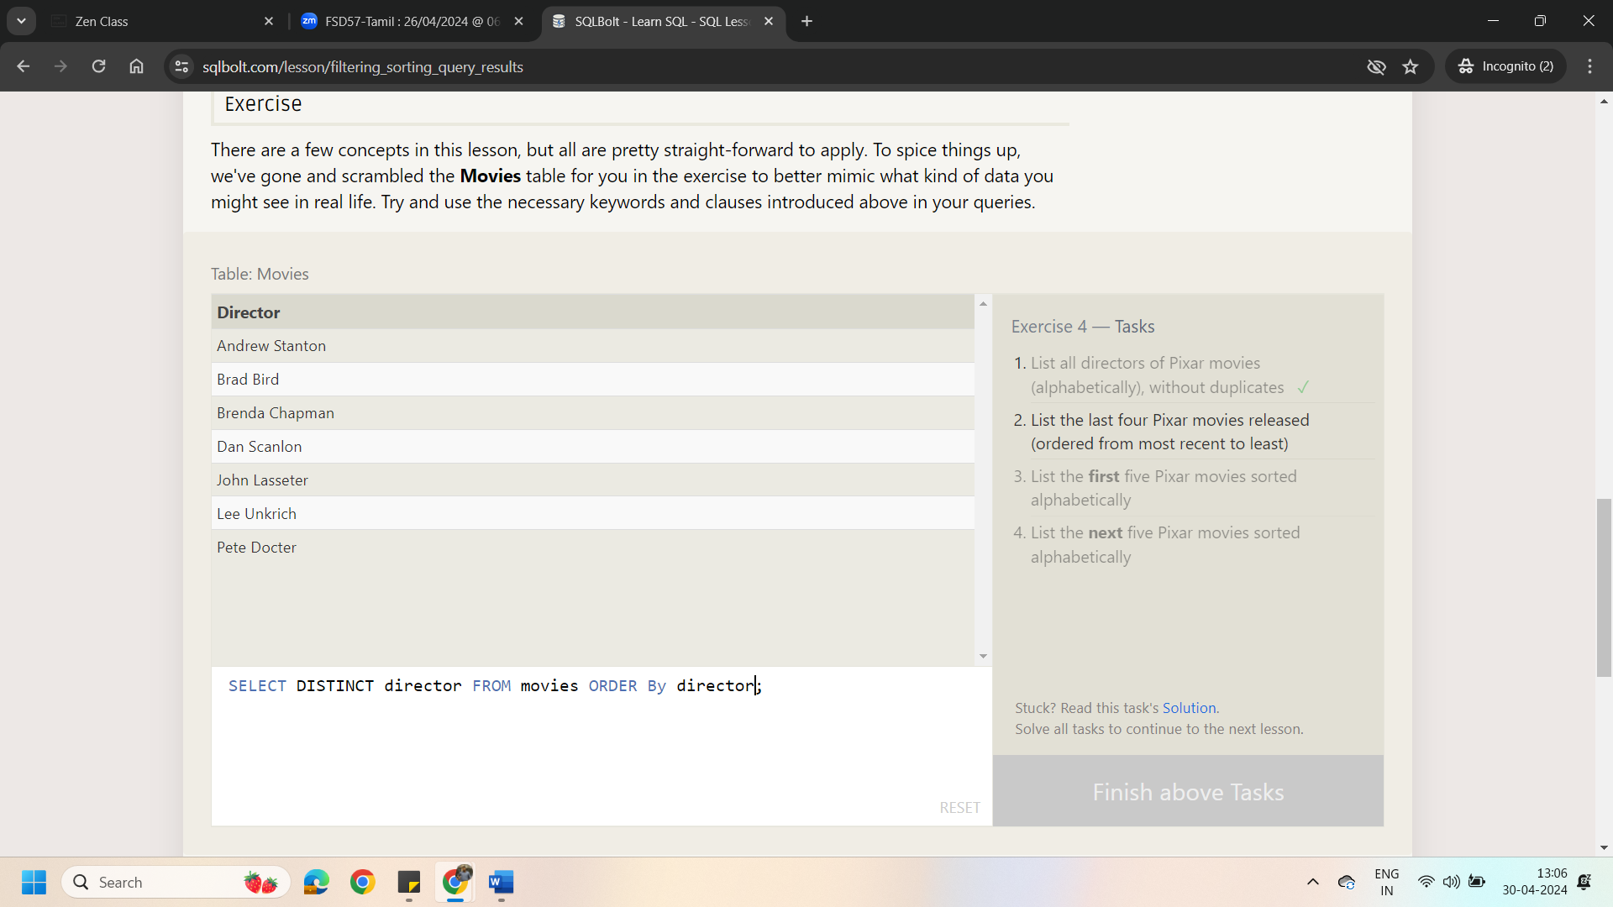

2.List the last four Pixar movies released (ordered from most recent to least)

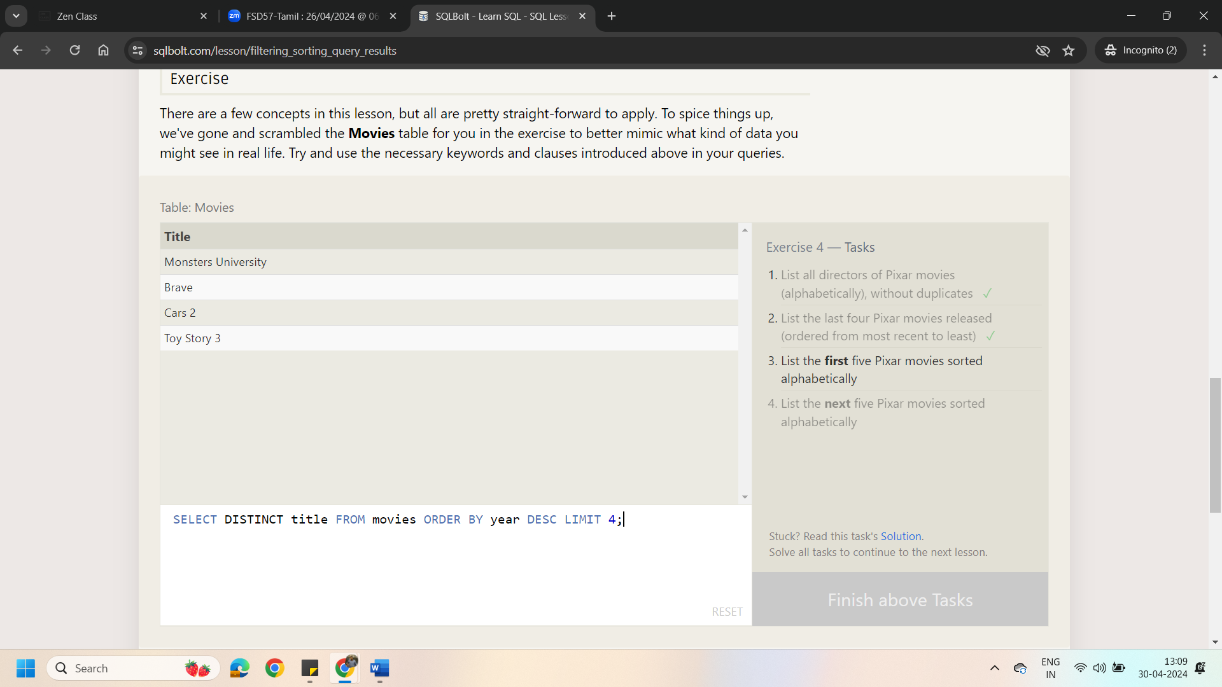

3.List the **first** five Pixar movies sorted alphabetically

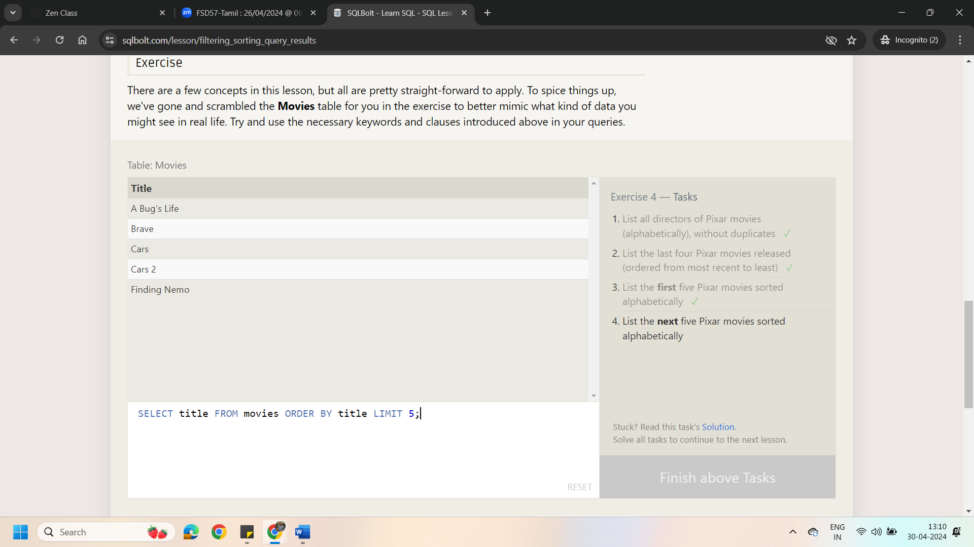

4.List the **next** five Pixar movies sorted alphabetically

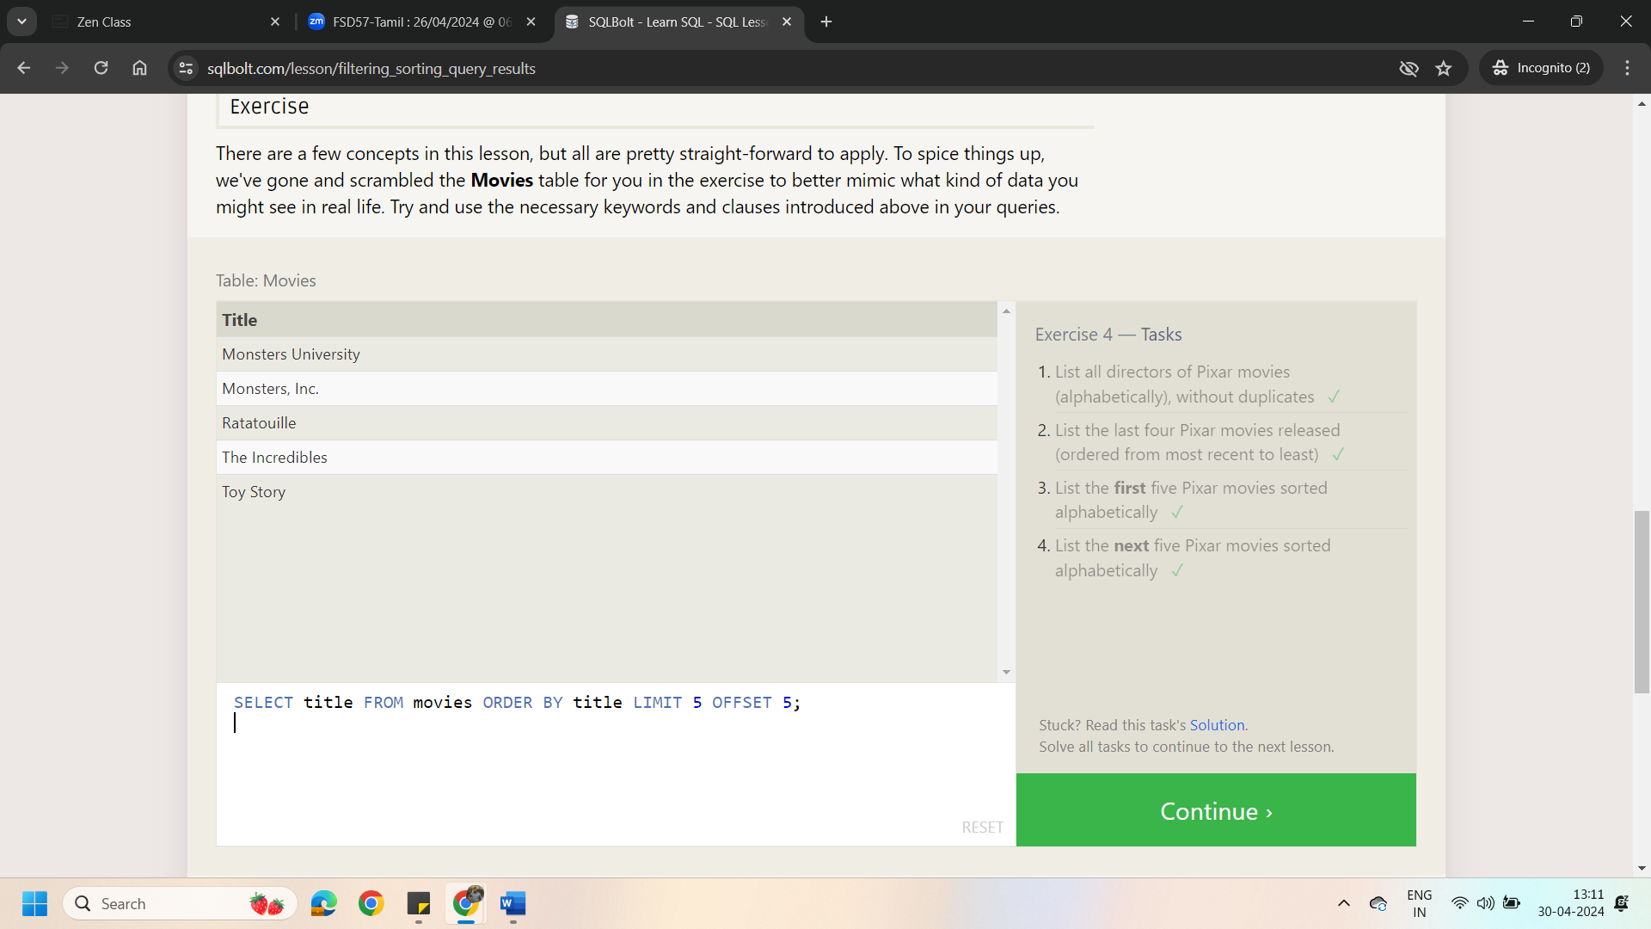

Lesson 5: Review Simple SELECT Queries

1. List all the Canadian cities and their populations

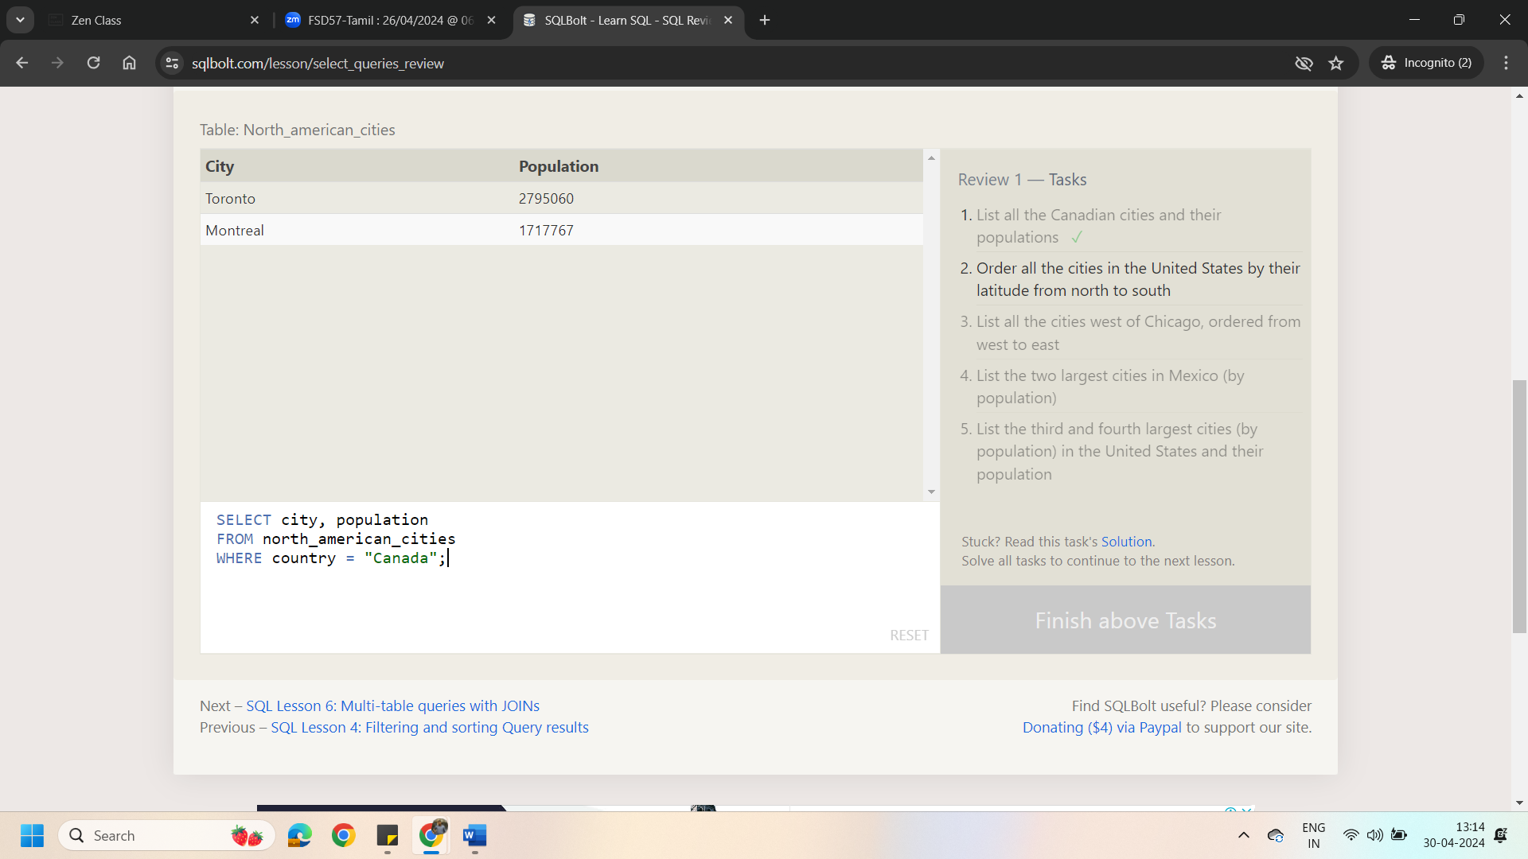

1. Order all the cities in the United States by their latitude from north to south

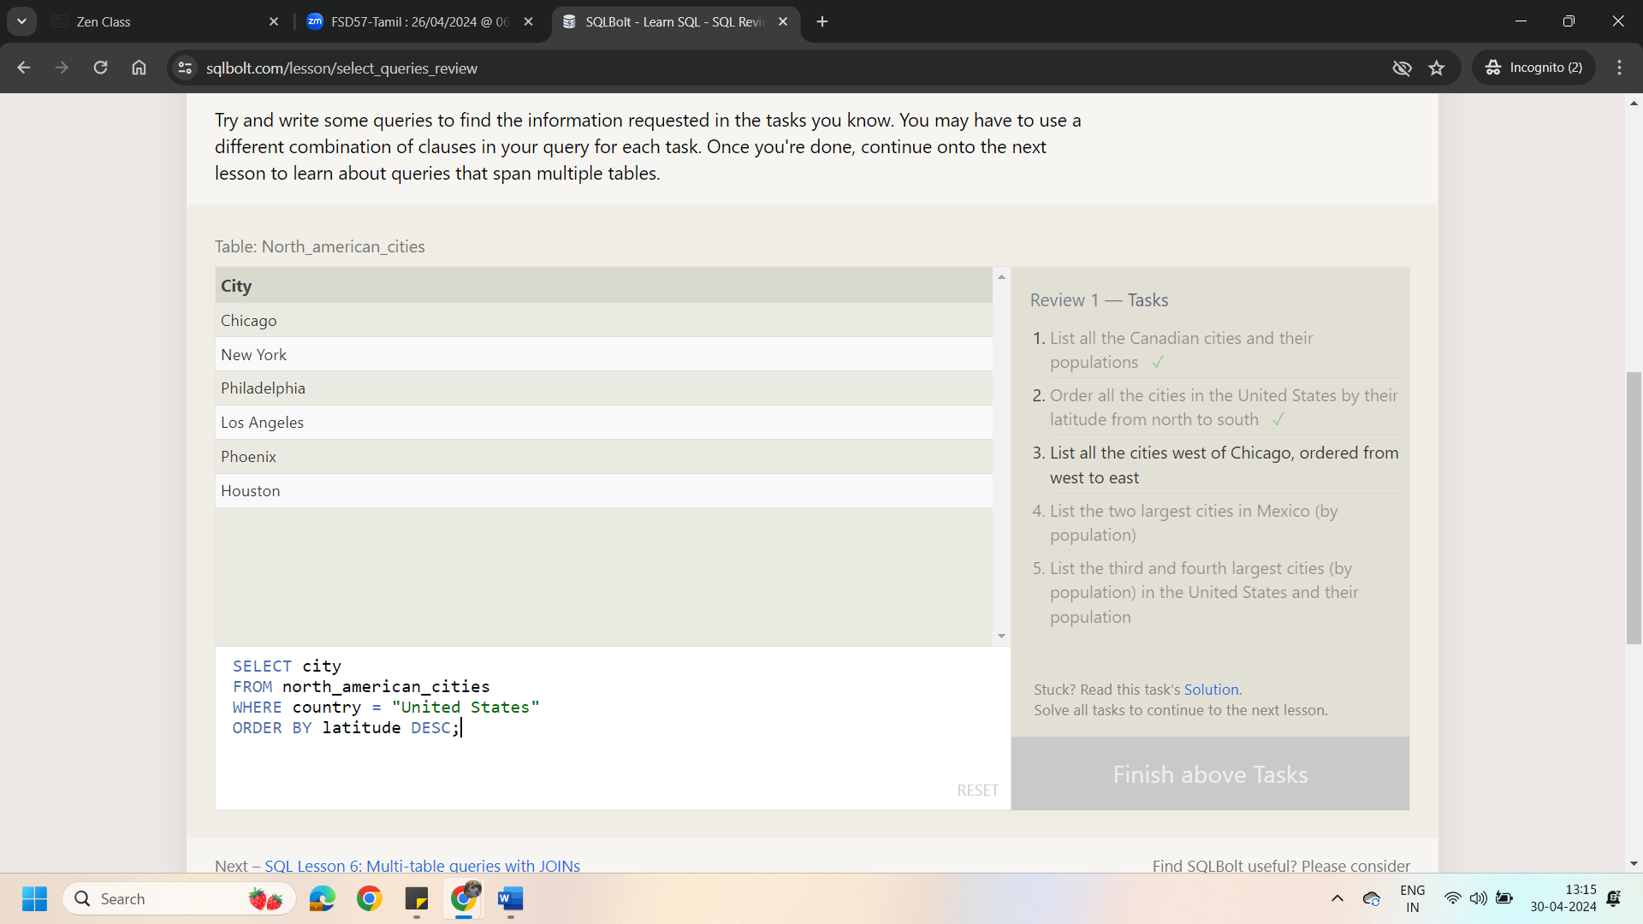

1. List all the cities west of Chicago, ordered from west to east

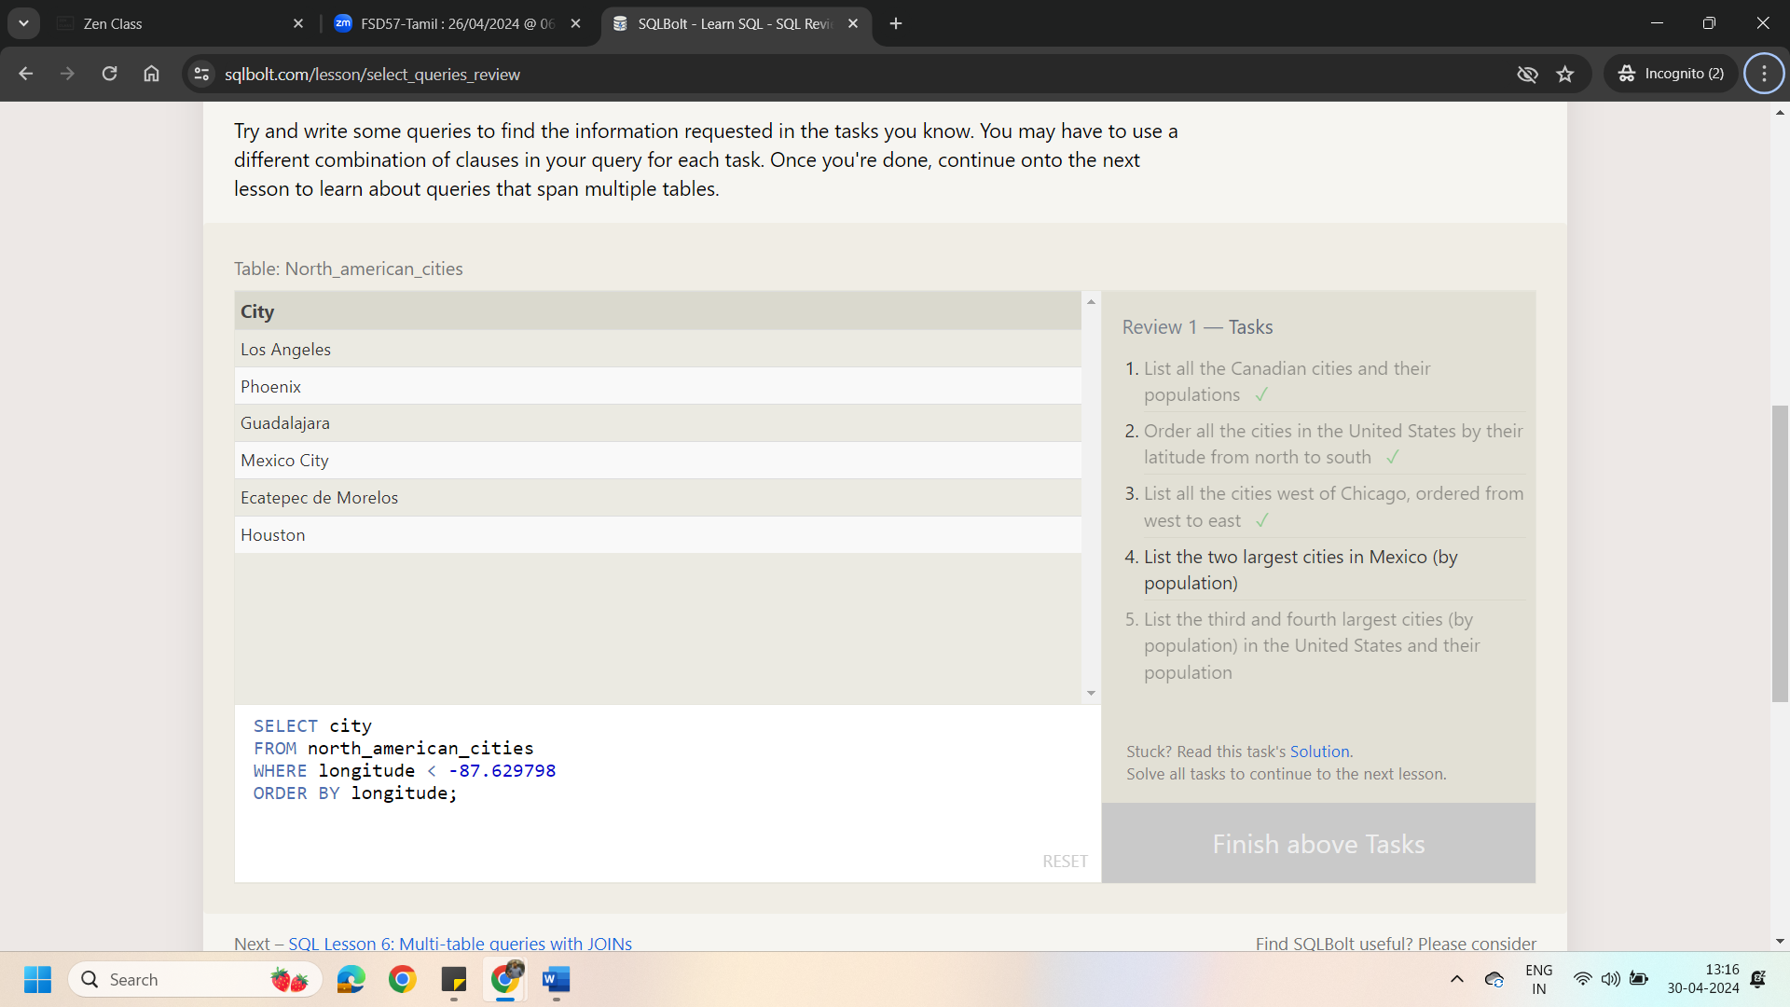

1. List the two largest cities in Mexico (by population)

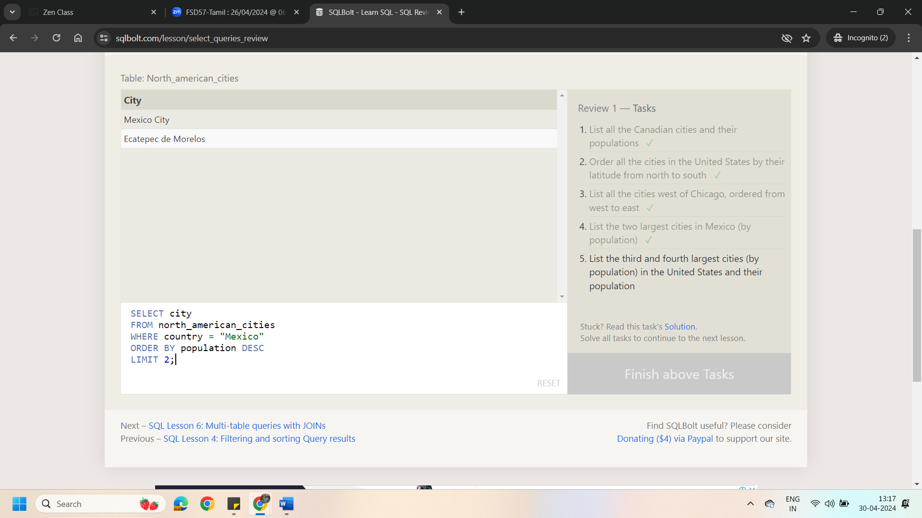

1. List the third and fourth largest cities (by population) in the United States and their population

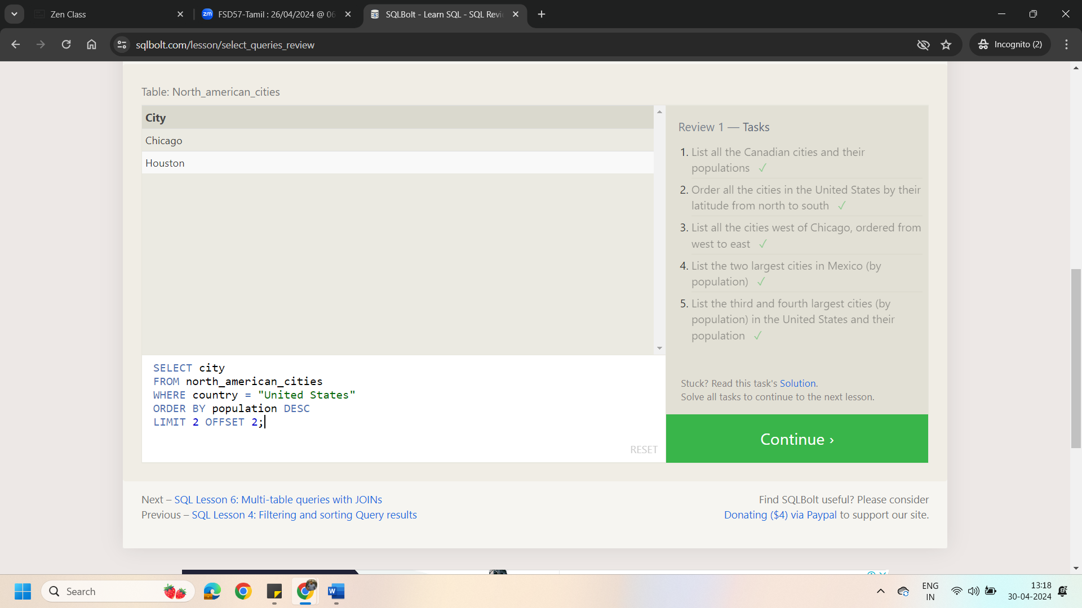

Lesson 6: Multitable Queries with Joins

1. Find the domestic and international sales for each movie

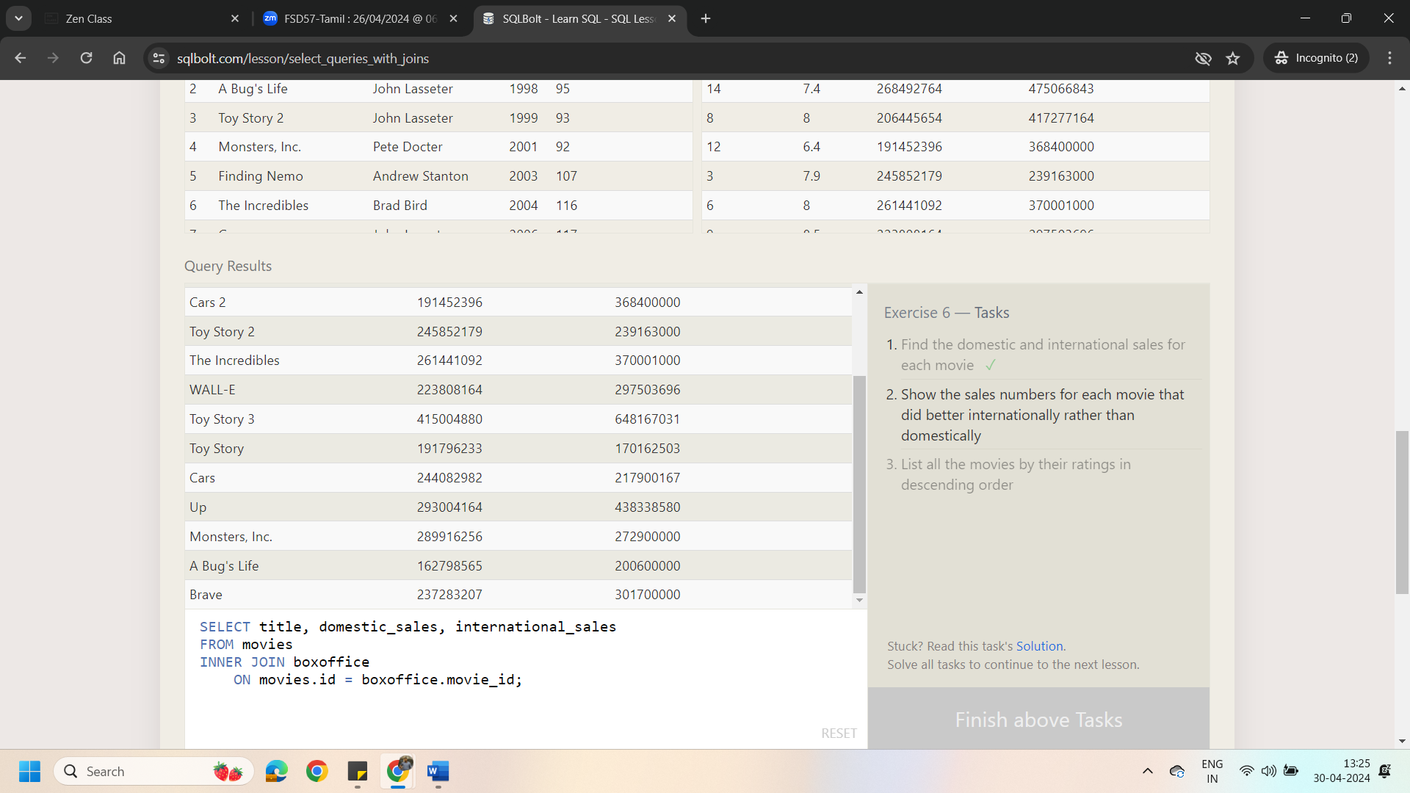

1. Show the sales numbers for each movie that did better internationally rather than domestically

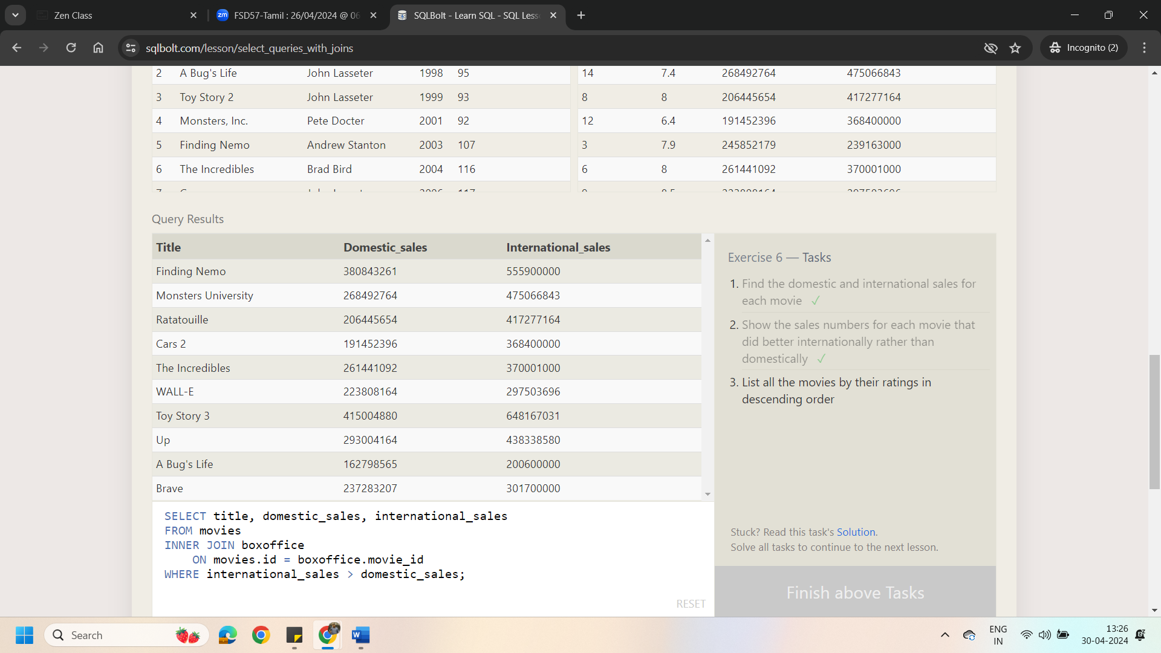

1. List all the movies by their ratings in descending order

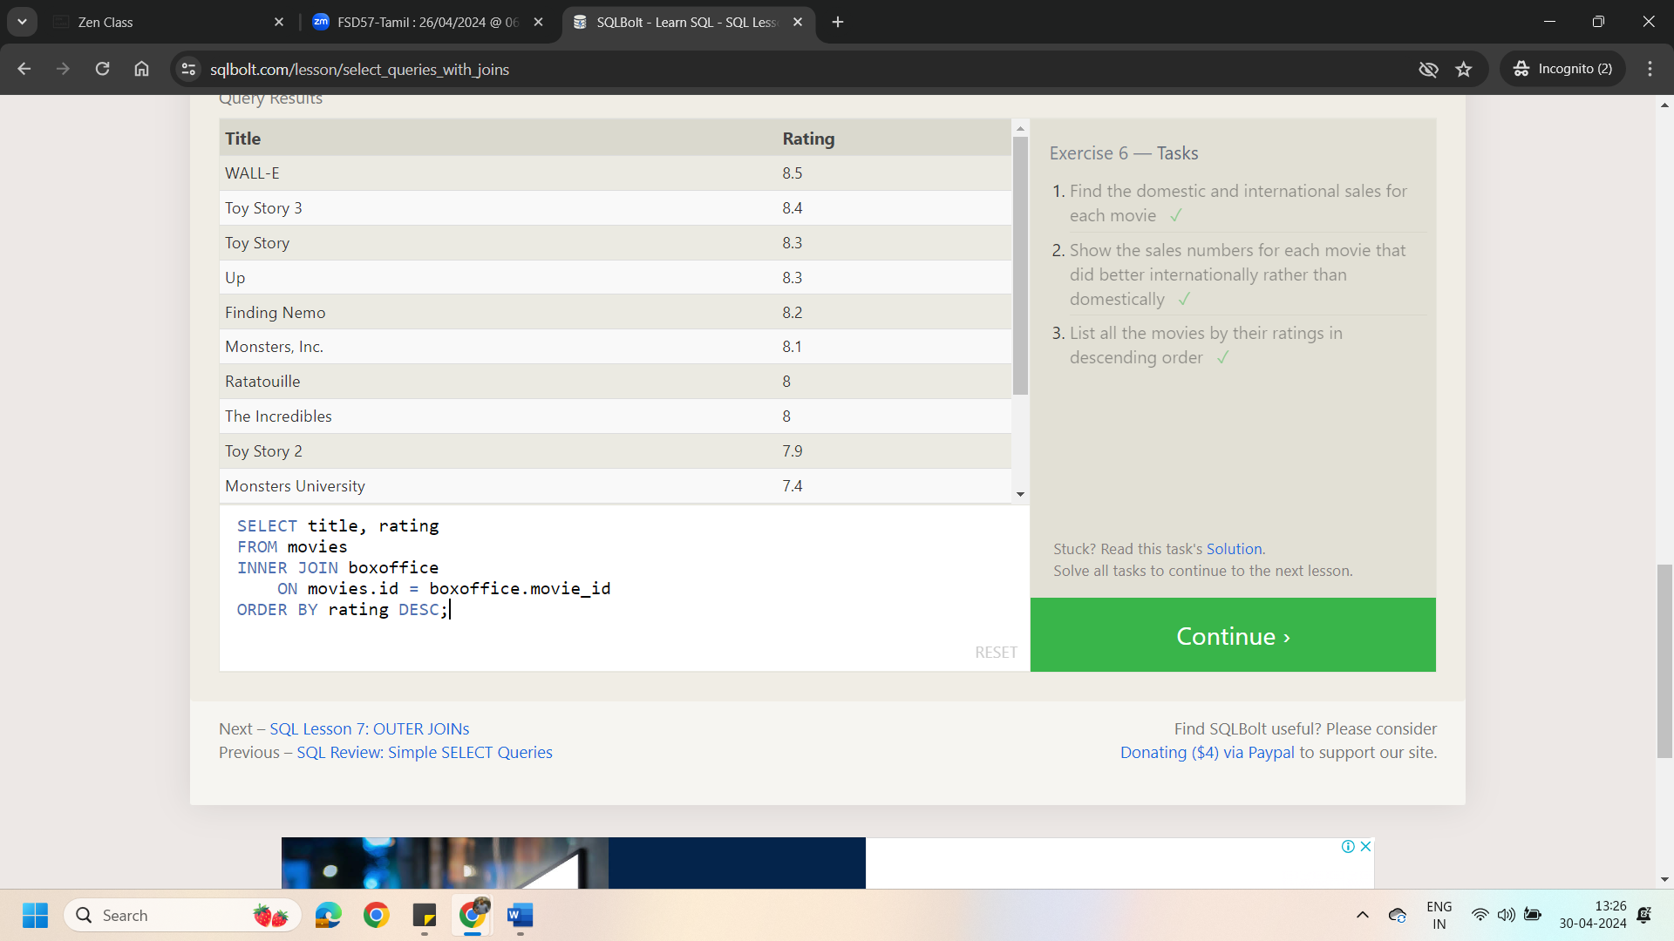

Lesson 6: Outer Joins

1. Find the list of all buildings that have employees

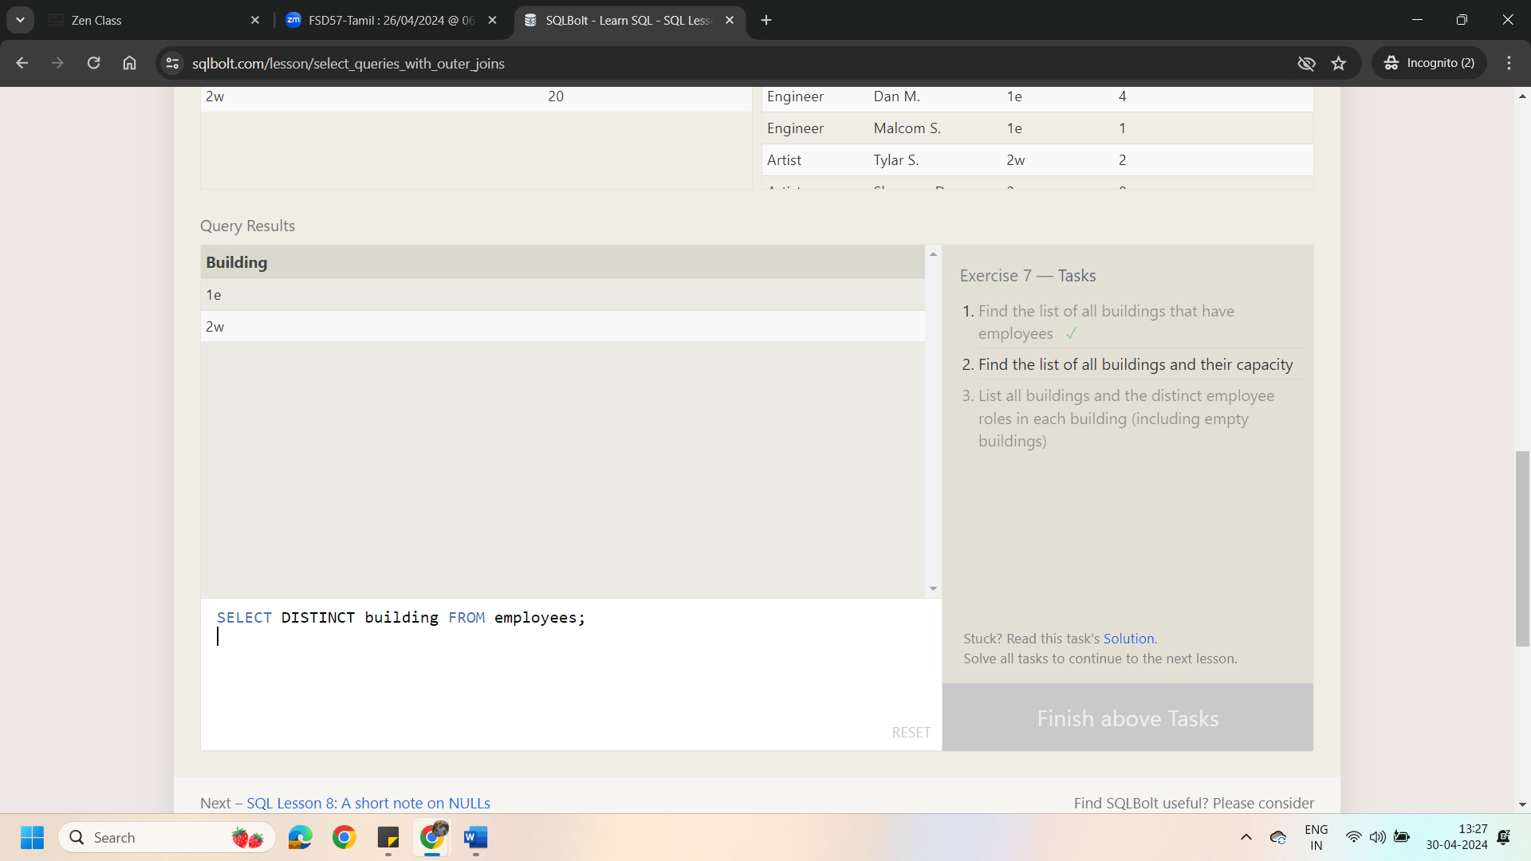

1. Find the list of all buildings and their capacity

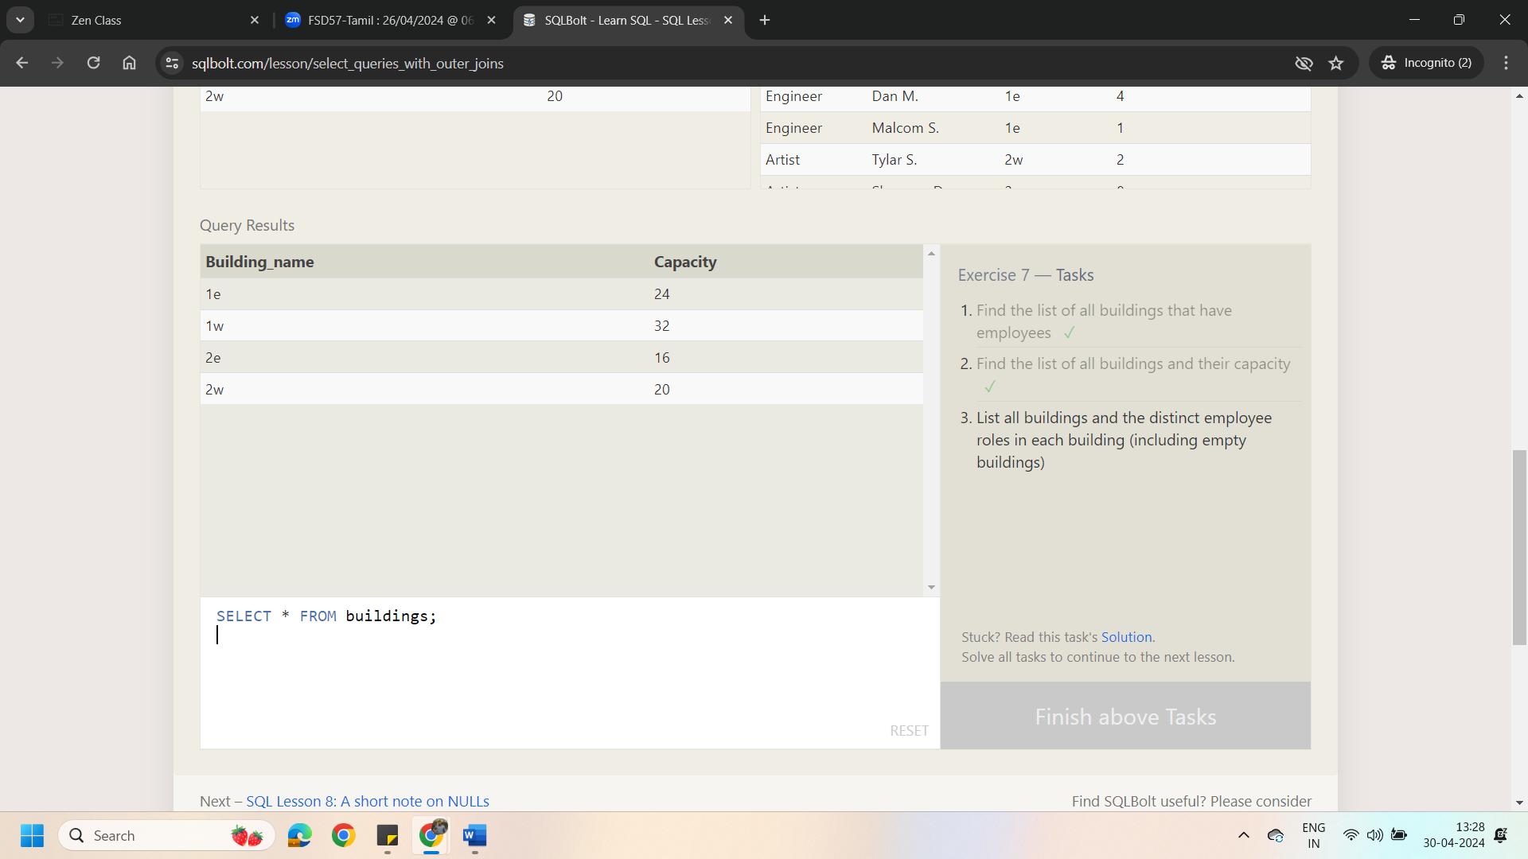

1. List all buildings and the distinct employee roles in each building (including empty buildings)

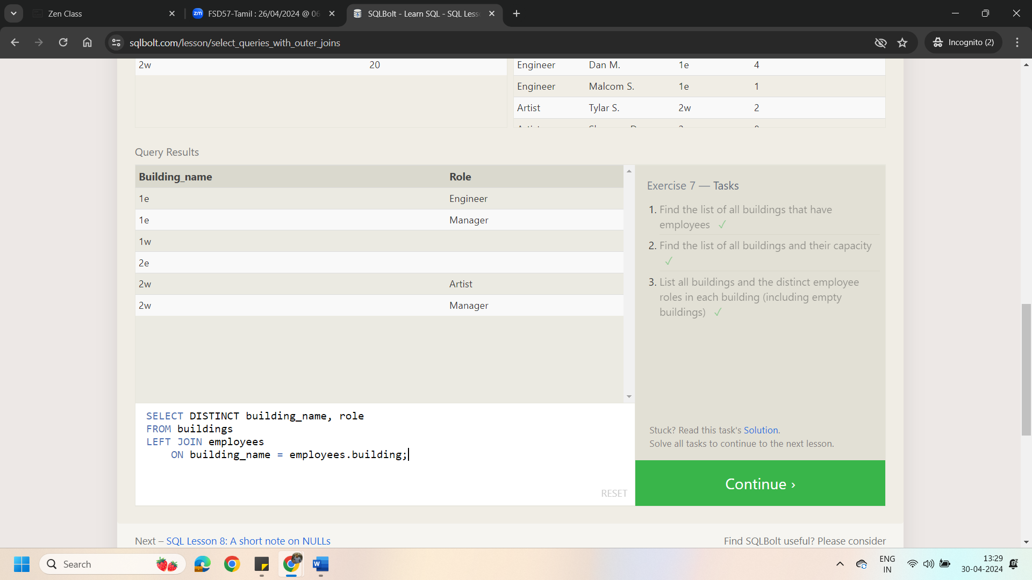

Lesson 6: A Short note on NULLs

1. Find the name and role of all employees who have not been assigned to a building

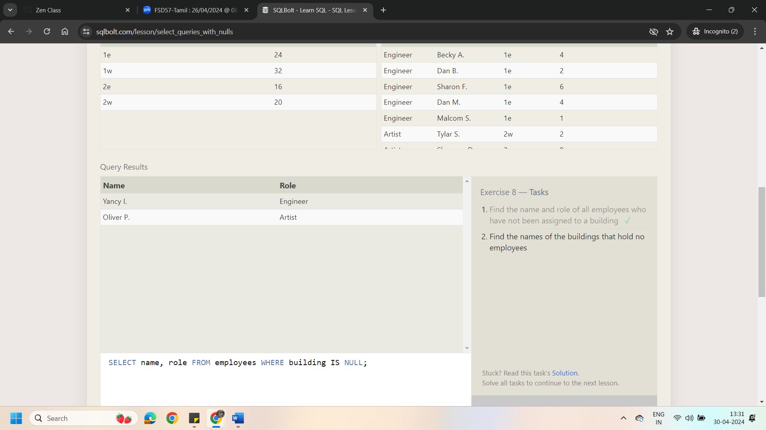

2.Find the names of the buildings that hold no employees

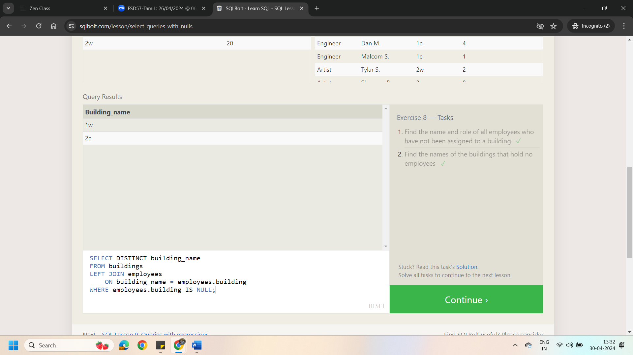

Lesson 6: Queries with Expression

1.List all movies and their combined sales in millions of dollars

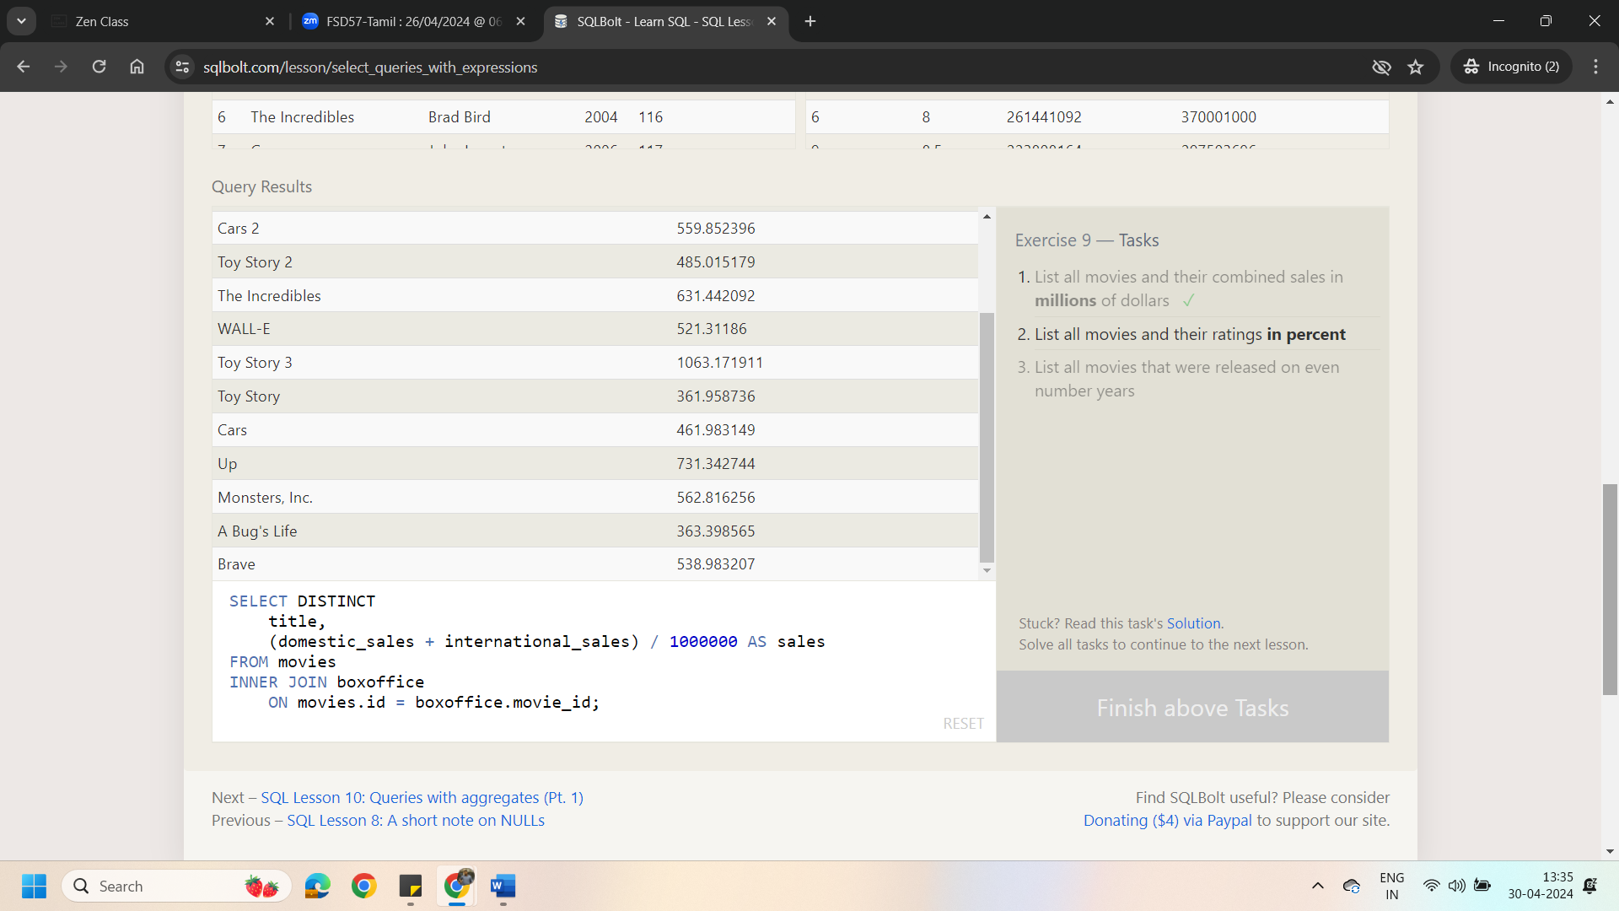

2.List all movies and their ratings in percent

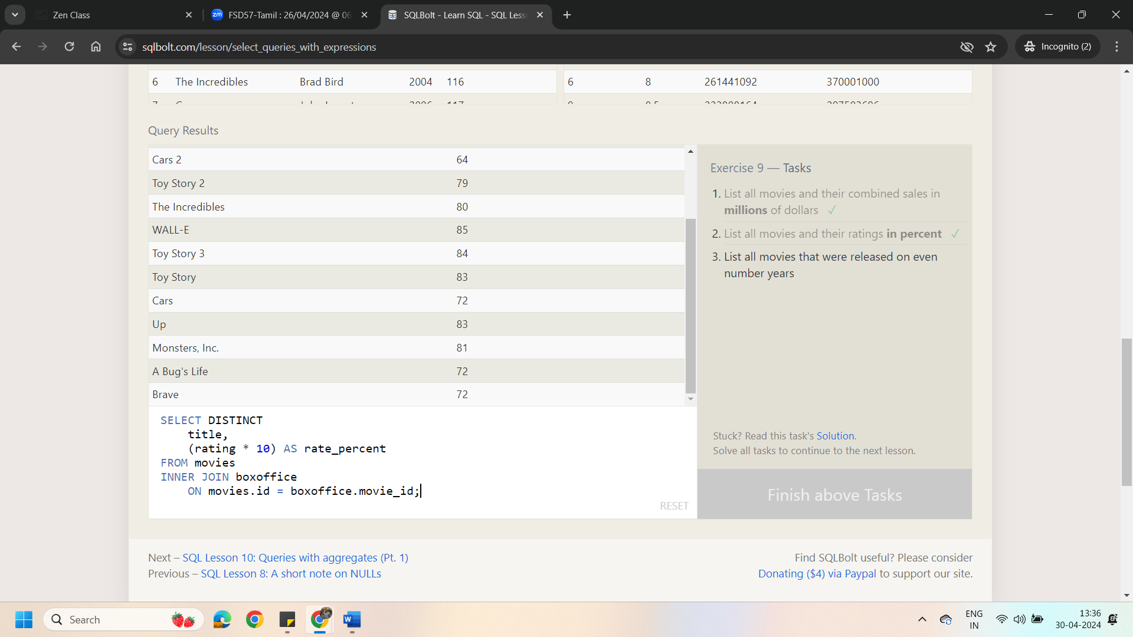

3.List all movies that were released on even number years

